**Hindi Vidya Prachar Samiti’s**

**Ramniranjan Jhunjhunwala College of Arts, Science & Commerce**

**(Empowered Autonomous College)**



**Affiliated to**

**UNIVERSITY OF MUMBAI**

**DEPARTMENT OF INFORMATION TECHNOLOGY**

**2025 - 2026**

**M.Sc. (IT) PART 2 - SEM IV**

**RJSPIT302P – Machine Learning**

**Name: Vishwakarma Shivam Suresh Sushila**

**Roll No: 6709**

**Hindi Vidya Prachar Samiti’s**

**Ramniranjan Jhunjhunwala College of Arts, Science & Commerce**

**(Empowered Autonomous College)**

***Certificate***



**This is to certify that Mr. Vishwakarma Shivam Suresh Suhila Roll No 6709 of M.Sc.(I.T.) Part-1 class has completed the required number of experiments in the subject of Machine Learning in the Department of Information Technology during the academic year 2025 - 2026 .**

* *

**Professor In-Charge Co-ordinator of IT Department**

**Prof. Bharati Bhole Prof. Bharati Bhole**

**College Seal & Date Examiner**

### **INDEX**

|  |  |  |  |
| --- | --- | --- | --- |
| **Sr No.** | **Title** | **Date** | **Remarks** |
| 1 | Solving a Business Problem | Jul 14, 2025 |  |
| 2 | Handling Numerical, Categorical, Textual and Date-Time data | Jul 21, 2025 Jul 28, 2025 |  |
| 3 | Linear Regression | Aug 4, 2025 |  |
| 4 | Trees and Forests | Aug 11, 2025 |  |
| 5 | K-Nearest Neighbors Classifier | Sep 12, 2025 |  |
| 6 | Logistic Regression | Sep 18, 2025 |  |
| 7 | Support Vector Machines | Sep 18, 2025 |  |
| 8 | Naive Bayes | Sep 18, 2025 |  |
| 9 | Clustering | Sep 19, 2025 |  |
| 10 | Association rule learning | Sep 22, 2025 |  |

### **Practical 1: Solving a Business Problem**

Jul 14, 2025

**Identifying Business Problems:**

The first step in any data-driven project is identifying the business problem. A business problem can range from improving customer retention, forecasting sales, optimizing supply chains, to enhancing product recommendations. Proper identification is crucial, as it lays the foundation for building data models and choosing the right methodologies.

**Key steps to identify business problems:**

* Stakeholder Consultation: Understand the pain points from those directly impacted by the problem, like business leaders or customers.
* Defining Objectives: Clearly articulate the objective, whether it's reducing operational costs, increasing revenue, or improving customer satisfaction.
* Understanding Constraints: Identify any limitations, such as data availability, budget, timeline, or resource constraints.
* Contextual Analysis: Analyze the broader context of the business, industry trends, and competitive positioning to ensure the solution aligns with long-term goals.
* Defining Alternative Models: Once a problem is defined, it is essential to explore multiple models to ensure that the chosen solution is effective. Data scientists must develop and test various models to determine which one best meets the business objectives.

**Steps to defining alternative models:**

* Data Collection: Gather data relevant to the problem, ensuring it's clean, complete, and representative.
* Model Hypothesis Development: Based on the problem, develop hypotheses and decide whether a predictive, descriptive, or prescriptive model is appropriate.
* Model Selection: Common models include:

➔ Supervised Learning Models (e.g., regression, decision trees) for prediction.

➔ Unsupervised Learning Models (e.g., clustering, association) for patternrecognition.

* Optimization Models for resource management or scheduling.
* Model Evaluation: Compare multiple models using key metrics (accuracy, precision, recall) to identify the most effective one.
* Risk and Sensitivity Analysis: Analyze the robustness of models under different conditions to select the one best suited for real-world scenarios.

By exploring alternative models, businesses can avoid committing to a single approach prematurely and instead make an informed decision on the model that most effectively addresses their needs.

**Feature selection** is the process of selecting the most relevant variables (features) from a dataset that contribute significantly to the target variable output). The goal is to improve model performance by reducing dimensionality, avoiding overfitting, and enhancing interpretability. Feature selection reduces noise and computational complexity, leading to faster and more accurate models.

**Feature engineering** involves transforming raw data into meaningful features that improve model performance. It's the art of creating new features or modifying existing ones to better capture underlying patterns and relationships within the data.

#### **Aim A: Identifying a Business Problem and Defining the Problem Statement.**

**Problem Statement:**

* Diabetes is a chronic disease that affects millions of people worldwide. Early detection of diabetes can help in managing and preventing severe complications. The goal is to develop a predictive model that can accurately classify individuals as diabetic or non-diabetic based on several health metrics such as glucose levels, BMI, age, and others.
* The task involves using machine learning techniques to select the most relevant features that contribute to predicting whether an individual has diabetes. Proper feature selection can improve model performance, reduce overfitting, and enhance the interpretability of the model.

**Step 1: Import Libraries**

We first imported the necessary libraries like NumPy, Pandas, and Matplotlib for data handling and visualization. From scikit-learn, we imported the diabetes dataset, the Linear Regression model, and evaluation metrics.

#### 

**Step 2: Load Dataset**

We used the Diabetes dataset provided by sklearn.datasets.

The dataset contains information about patients, including medical features (like age, BMI, blood pressure, etc.).

The target variable is a measure of disease progression (a numerical value we want to predict).

We stored the data in a DataFrame for easy visualization.

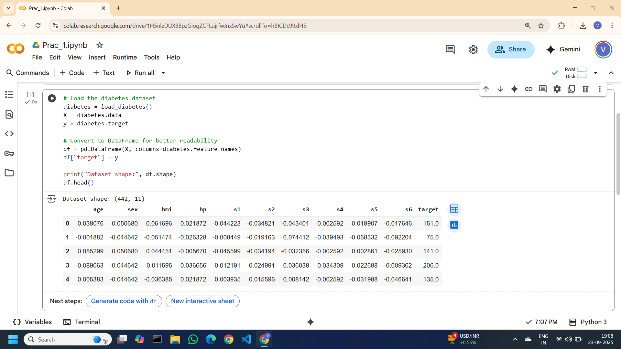

**Step 3: Split into Training and Testing Sets**

To build and test our model fairly, we split the dataset into:

Training data (80%) → used to train the model.

Testing data (20%) → used to evaluate how well the model performs on unseen data.

This was done using train_test_split.

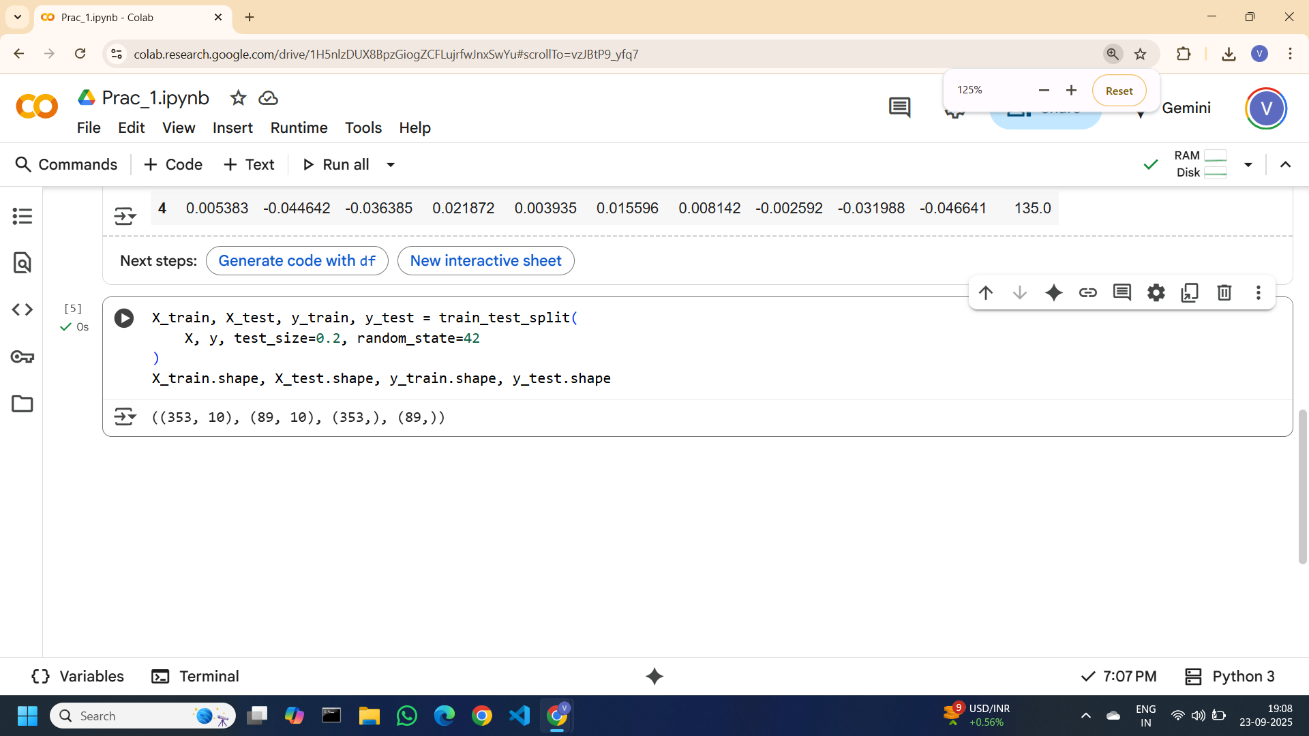

**Step 4: Create and Train Linear Regression Model**

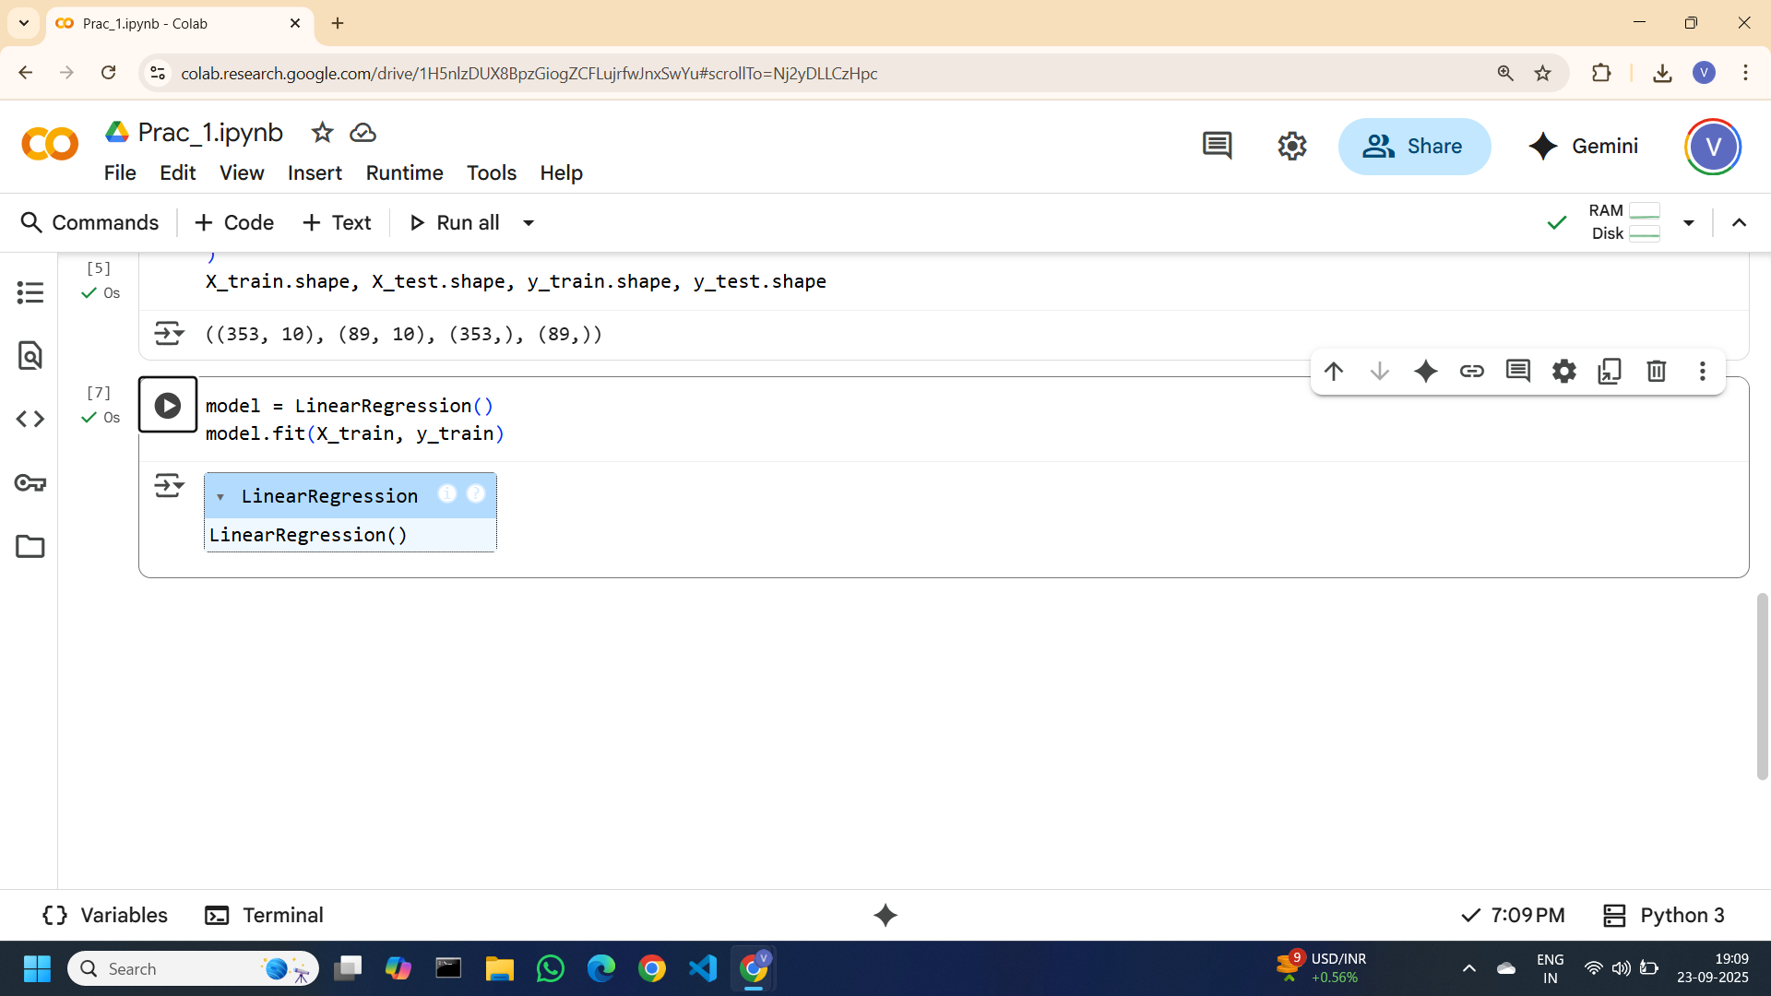

**Step 5: Make Predictions**

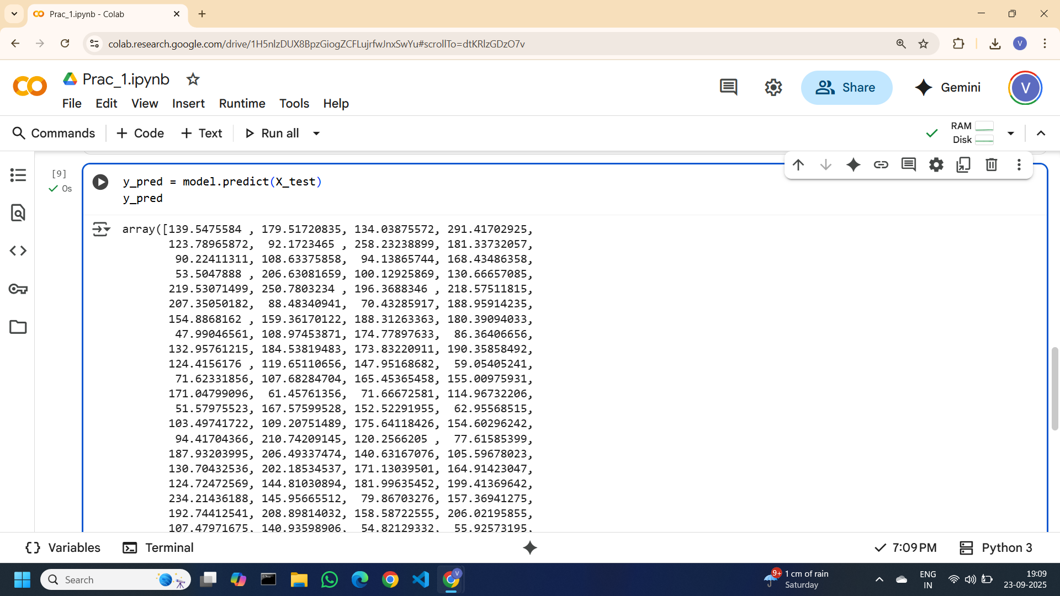

**Step 6: Evaluate the Model**

We measured the model’s performance using two metrics:

Mean Squared Error (MSE): Tells us how far the predicted values are from the actual values (lower is better).

R² Score: Explains how well the model fits the data. An R² close to 1 means a good fit.

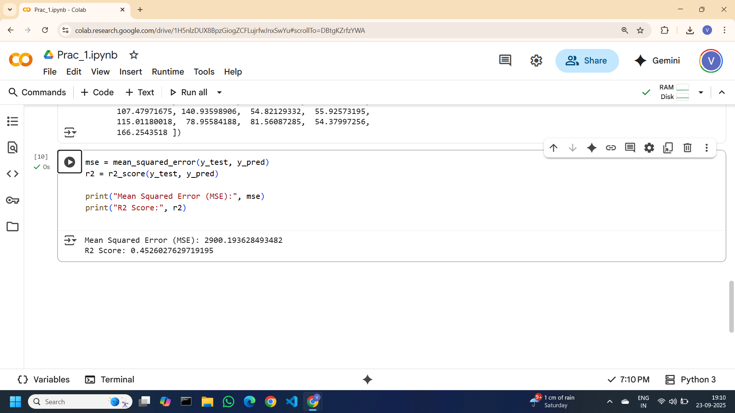

**Step 7: Plot Actual vs Predicted Values**

We created a scatter plot of actual vs predicted values.

Each blue dot represents a prediction compared to the actual outcome.

The red dashed line shows the ideal scenario (where predicted = actual).

The closer the points are to the red line, the better the model is performing

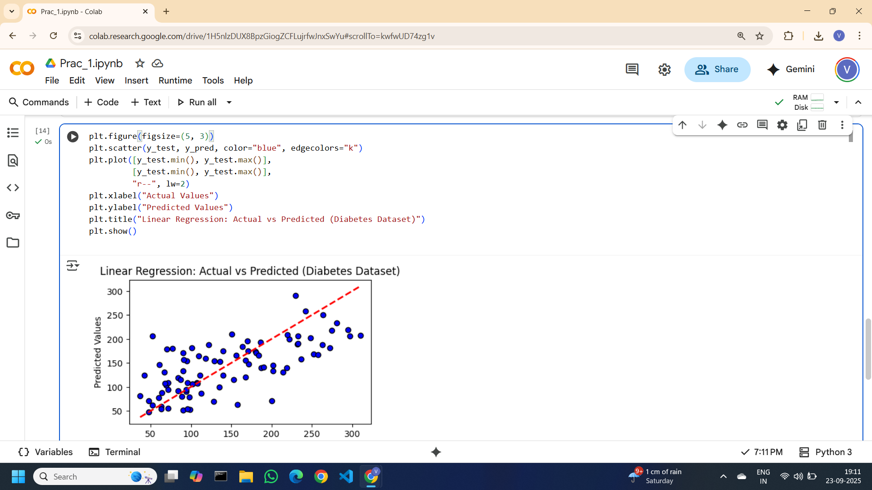

#### **Aim B: Python Program to Demonstrate Feature Selection Methods.**

**Dataset:** piama_indians_diabetes.csv

**Link:** [Pima Indians Diabetes Database](https://www.kaggle.com/datasets/uciml/pima-indians-diabetes-database?resource=download)

1. **Univariate Selection**

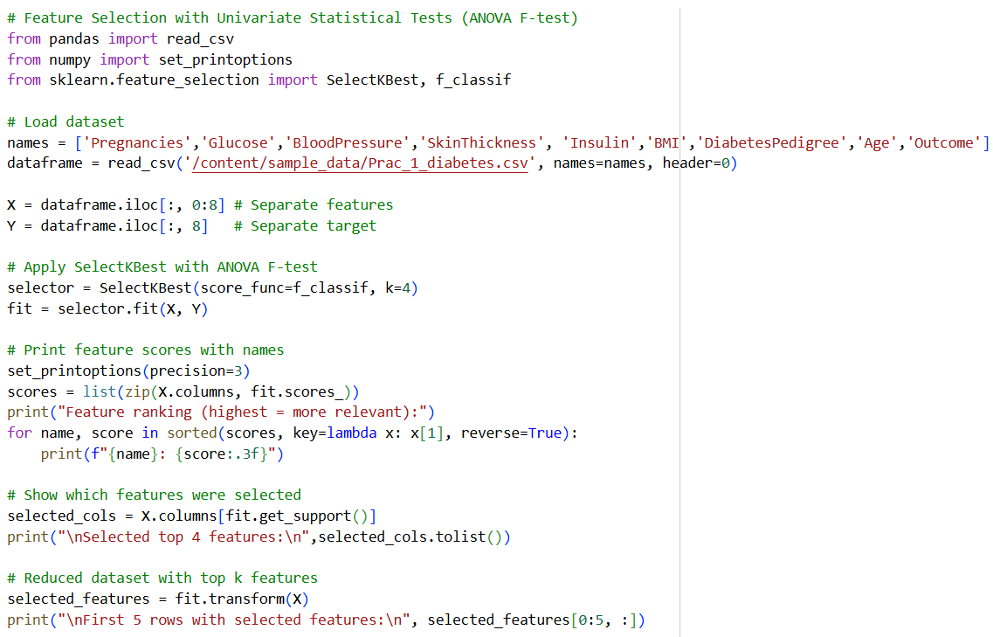

**Output**

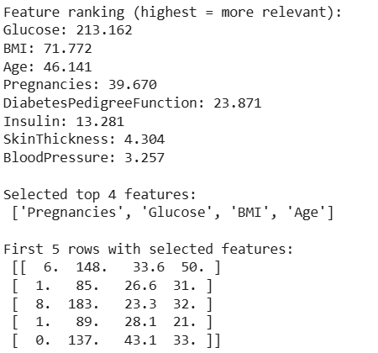

1. **Recursive Feature Selection**

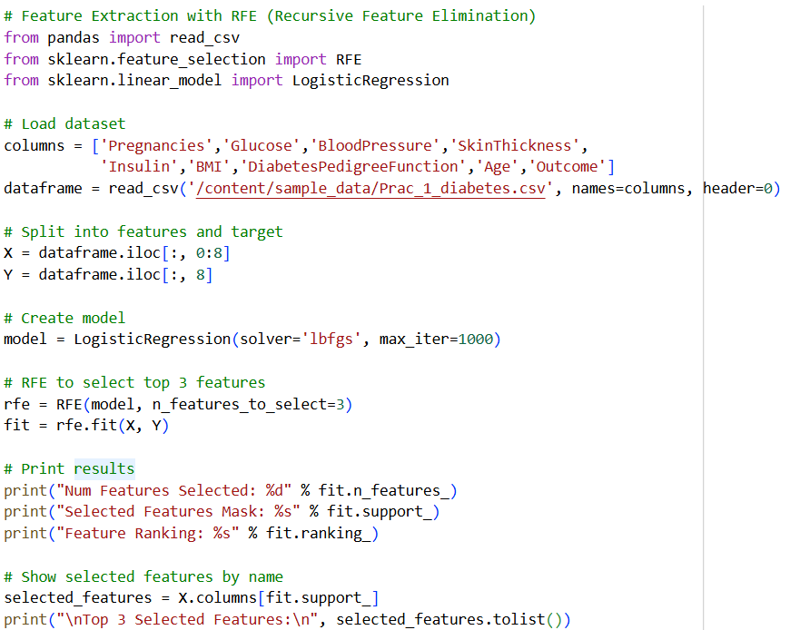

**Output**

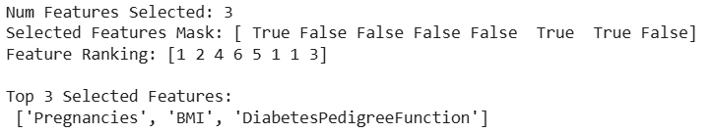

1. **Principal Component Analysis**

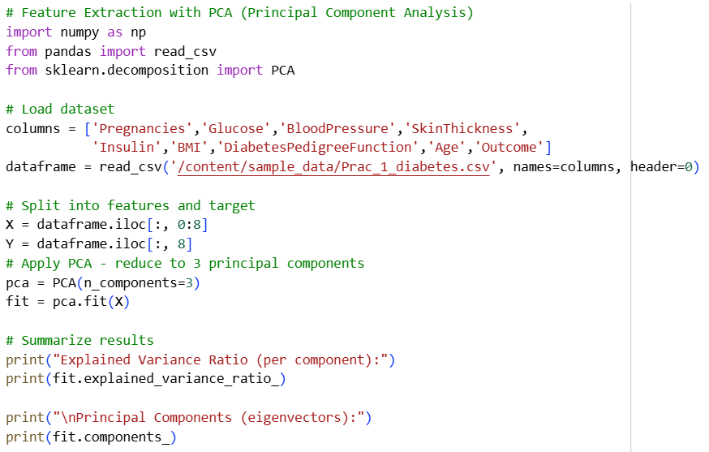

**Output**

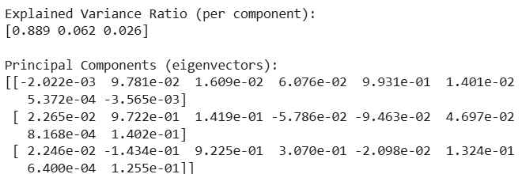

1. **Feature importance**

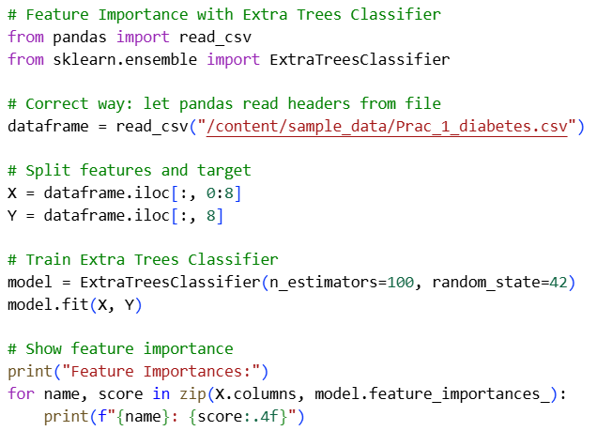

**Output**

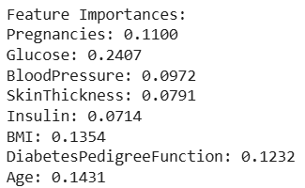

Colab file link: [Prac_1.ipynb](https://colab.research.google.com/drive/1H5nlzDUX8BpzGiogZCFLujrfwJnxSwYu#scrollTo=TpwXo1Kp3WJr)

### **Practical 2: Handling Numerical, Categorical, Textual and Date-Time data**

Jul 21, 2025 & Jul 28, 2025

#### **A. Handling Numerical Data**

**Rescaling Features Using MinMax Scalar**

1. Use scikit-learn's MinMaxScaler to rescale a feature array in the range of 0 to 1 and also in the range of -1 to 1.

Array: -200, -100, 0, 100, 200

Code

# Load libraries

import numpy as np

from sklearn import preprocessing

# Create feature

feature = np.array([

[-200],

[-100],

[0],

[100],

[200]

])

# Create scaler

minmax_scale1 = preprocessing.MinMaxScaler(feature_range=(0, 1)) # range 0 to 1

minmax_scale2 = preprocessing.MinMaxScaler(feature_range=(-1, 1)) # range -1 to 1

# Scale feature

scaled_feature1 = minmax_scale1.fit_transform(feature)

scaled_feature2 = minmax_scale2.fit_transform(feature)

# Show feature

scaled_feature1, scaled_feature2

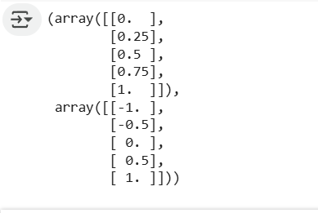

2. Use scikit-learn's MinMaxScaler to rescale the following features.

Feature_1: 10,20,30,40,50

Feature_2: 500,1000,3000,25000,100

import pandas as pd

from sklearn import preprocessing

data = {

"feature1": [10, 20, 30, 40, 50],

"feature2": [500, 1000, 3000, 25000, 100]

}

df = pd.DataFrame(data)

print(f"DataFrame:\n{df}")

scaler = preprocessing.MinMaxScaler(feature_range=(0, 1))

scaled_data = scaler.fit_transform(df)

scaled_df = pd.DataFrame(scaled_data, columns=df.columns)

print(f"\nScaled DataFrame:\n{scaled_df}")

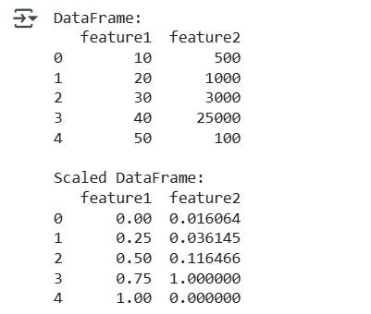

**Normalizing Features using StandardScalar**

Ex 1: Use scikit-learn's StandardScalar to normalize a feature array with mean 0 and standard deviation 1.

Array: -200, -100, 0, 100, 200

import numpy as np

from sklearn import preprocessing

x = np.array([

[-200],

[-100],

[0],

[100],

[200]

])

# Create scaler

scaler = preprocessing.StandardScaler()

# Transform the feature

standardized = scaler.fit_transform(x)

# Show feature

standardized

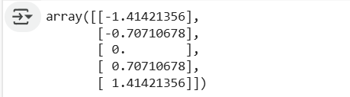

**Multiple feature**

# Multiple features

import numpy as np

import pandas as pd

from sklearn import preprocessing

data = {

'Feature_1': [10, 20, 30, 40, 50],

'Feature_2': [500, 1000, 3000, 25000, 100]

}

df = pd.DataFrame(data)

print("Original DataFrame:")

display(df)

scaler = preprocessing.StandardScaler()

standardized_data = scaler.fit_transform(df)

standardized_df = pd.DataFrame(standardized_data, columns=df.columns)

print("\nStandardized DataFrame:")

display(standardized_df)

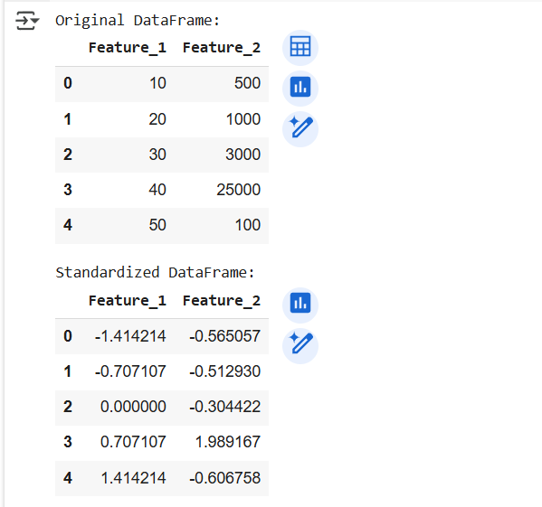

**Normalizing Features using RobustScalar**

Ex 1: Use scikit-learn's RobustScalar to normalize a feature array.

Array: -200, -100, 0, 10000, 200

# Load libraries

import numpy as np

from sklearn import preprocessing

# Create feature

x = np.array([

[-200],

[-100],

[0],

[10000],

[200]

])

# Create scaler

robust_scaler = preprocessing.RobustScaler()

# Transform feature

robust_scaled_feature = robust_scaler.fit_transform(x)

# Show feature

display(robust_scaled_feature)

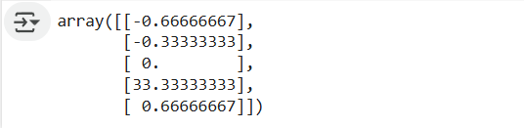

**Normalizing Features using Normalizer**

Ex 2: Use scikit-learn's Normalizer to normalize the following features with l1, l2 and max norm.

Feature_1: 10,20,30,40,50

Feature_2: 500,1000,3000,25000,100

# Load libraries

import numpy as np

import pandas as pd

from sklearn import preprocessing

# Create features

data = {

'Feature_1': [10, 20, 30, 40, 50],

'Feature_2': [500, 1000, 3000, 25000, 100]

}

df = pd.DataFrame(data)

print("Original DataFrame:")

display(df)

# Create normalizer

normalizer_l1 = preprocessing.Normalizer(norm='l1')

normalizer_l2 = preprocessing.Normalizer(norm='l2')

normalizer_max = preprocessing.Normalizer(norm='max')

# Transform features with different norms

normalized_data_l1 = normalizer_l1.transform(df)

normalized_data_l2 = normalizer_l2.transform(df)

normalized_data_max = normalizer_max.transform(df)

# Convert back to DataFrames for better visualization

normalized_df_l1 = pd.DataFrame(normalized_data_l1, columns=df.columns)

normalized_df_l2 = pd.DataFrame(normalized_data_l2, columns=df.columns)

normalized_df_max = pd.DataFrame(normalized_data_max, columns=df.columns)

# Show normalized features

print("\nNormalized DataFrame (l1 norm):")

display(normalized_df_l1)

print("\nNormalized DataFrame (l2 norm):")

display(normalized_df_l2)

print("\nNormalized DataFrame (max norm):")

display(normalized_df_max)

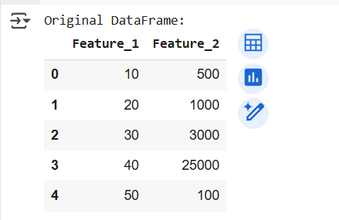

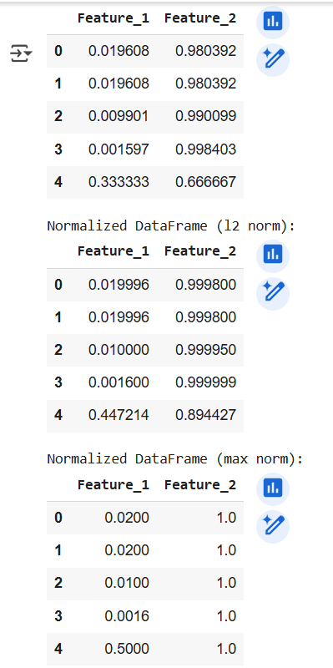

**Grouping Values using Clustering**

Ex 2: Use scikit-learn's Kmeans algorithm to group the following features into 2 groups.

Feature_1: 10,20,30,40,50,10,20,30

Feature_2: 500,1000,3000,25000,100,500,200,3000

import pandas as pd

from sklearn.cluster import KMeans

# Create features

data = {

'feature_1': [10, 20, 30, 40, 50, 10, 20, 30],

'feature_2': [500, 1000, 3000, 25000, 100, 500, 200, 3000]

}

df = pd.DataFrame(data)

# Make k-means clusterer

clusterer = KMeans(n_clusters=2, random_state=0, n_init=10)

# Fit clusterer

clusterer.fit(df) # Fit to the DataFrame

# Predict values

df["group"] = clusterer.predict(df) # Predict on the DataFrame

# View first few observations

display(df.head())

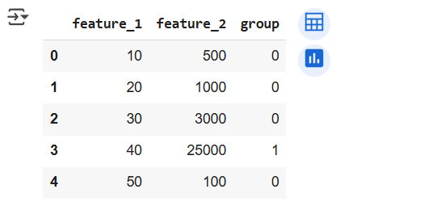

**Deleting Missing Values**

Ex1: Delete the observation with null values from the following data.

**features = np.array([**

**[1.1, 11.1],**

**[2.2, 22.2],**

**[np.nan, 22.2],**

**[3.3, 33.3],**

**[np.nan, 55]**

**])**

import numpy as np

import pandas as pd

# Create feature array with null values

features = np.array([

[1.1, 11.1],

[2.2, 22.2],

[np.nan, 22.2],

[3.3, 33.3],

[np.nan, 55]

])

# Convert to DataFrame

df = pd.DataFrame(features, columns=['feature_1', 'feature_2'])

print("Original DataFrame:")

display(df)

# Delete observations with null values

df_cleaned = df.dropna()

print("\nDataFrame after dropping null values:")

display(df_cleaned)

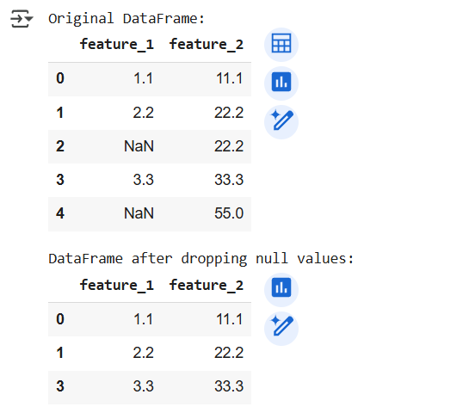

**Imputing the Missing Values**

Ex1: Replace the observation with null values with the mean value for the following data.

**features = np.array([**

**[1.1, 11.1],**

**[2.2, 22.2],**

**[np.nan, 22.2],**

**[3.3, 33.3],**

**[np.nan, 55]**

**[10, np.nan]**

**])**

import numpy as np

import pandas as pd

from sklearn.impute import SimpleImputer

# Create feature array with missing values (corrected the last row)

features = np.array([

[1.1, 11.1],

[2.2, 22.2],

[np.nan, 22.2],

[3.3, 33.3],

[np.nan, 55.0],

[10.0, np.nan]

])

# Convert to DataFrame for better display

df = pd.DataFrame(features, columns=['feature_1', 'feature_2'])

print("Original DataFrame:")

display(df)

# Impute missing values with the mean

mean_imputer = SimpleImputer(strategy='mean')

features_mean_imputed = mean_imputer.fit_transform(features)

# Impute missing values with the median

median_imputer = SimpleImputer(strategy='median')

features_median_imputed = median_imputer.fit_transform(features)

# Impute missing values with the most frequent value

most_frequent_imputer = SimpleImputer(strategy='most_frequent')

features_most_frequent_imputed = most_frequent_imputer.fit_transform(features)

# Convert imputed arrays back to DataFrames for display

df_mean_imputed = pd.DataFrame(features_mean_imputed, columns=df.columns)

df_median_imputed = pd.DataFrame(features_median_imputed, columns=df.columns)

df_most_frequent_imputed = pd.DataFrame(features_most_frequent_imputed, columns=df.columns)

print("\nDataFrame after imputing with mean:")

display(df_mean_imputed)

print("\nDataFrame after imputing with median:")

display(df_median_imputed)

print("\nDataFrame after imputing with most frequent:")

display(df_most_frequent_imputed)

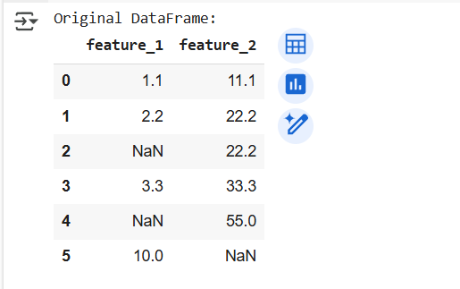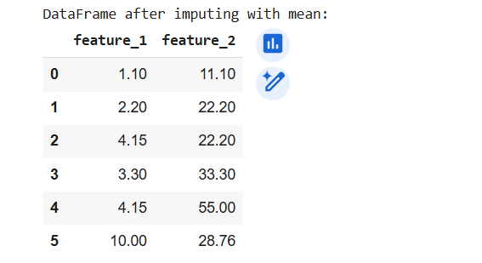

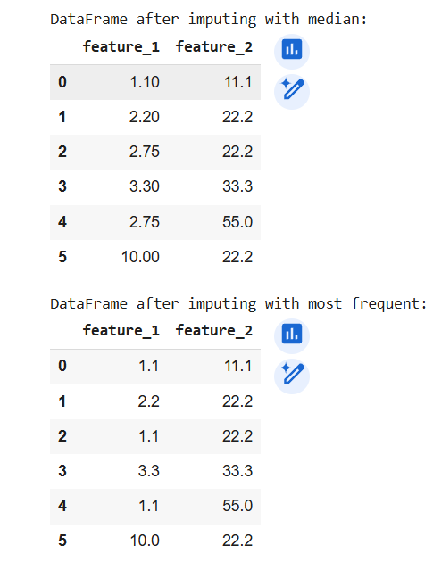

#### **B. Categorical Data Handling**

**Encoding Nominal Categorical Features using LabelBinerizer**

Ex1: Encode the employee’s department (Nominal) feature of following data using scikit-learn's LabelBinerizer.

Feature_1: 1,2,3,4,5

Feature_2: “Employee1”,“Employee2”,“Employee3”,“Employee4”,“Employee5”

Feature_3: “Grade1”,“Grade2”,“Grade3”,“Grade1”,“Grade2”,

Feature_4: “IT Dept”, “CS Dept”,”DS Dept”,“IT Dept”, “CS Dept”

import pandas as pd

from sklearn.preprocessing import LabelBinarizer

# Create DataFrame for features

data = {

'Feature_1': [1, 2, 3, 4, 5],

'Feature_2': ["Employee1", "Employee2", "Employee3", "Employee4", "Employee5"],

'Feature_3': ["Grade1", "Grade2", "Grade3", "Grade1", "Grade2"],

'Feature_4': ["IT Dept", "CS Dept", "DS Dept", "IT Dept", "CS Dept"]

}

df = pd.DataFrame(data)

print("Original DataFrame:")

display(df)

# Create LabelBinarizer

lb = LabelBinarizer()

# Fit and transform the 'Feature_4' column

dept_encoded = lb.fit_transform(df['Feature_4'])

# Convert the encoded feature back to a DataFrame for better visualization

encoded_df = pd.DataFrame(dept_encoded, columns=lb.classes_)

print("\nEncoded 'Feature_4' using LabelBinarizer:")

display(encoded_df)

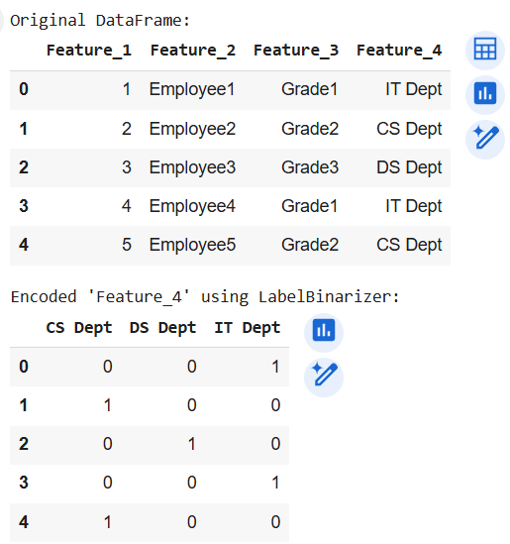

**Ex 2: Encode the employee’s Manager and department feature of following data using scikit-learn's MultiLabelBinerizer.**

EmpID: 1,2,3,4,5

Name: “Employee1”,“Employee2”,“Employee3”,“Employee4”,“Employee5”

Grade: “Grade1”,“Grade2”,“Grade3”,“Grade1”,“Grade2”,

Department: “IT Dept”, “CS Dept”,”DS Dept”,“IT Dept”, “CS Dept”

Manager: “Employee1”, “Employee2”, “Employee1”,“Employee2”, “Employee1”

import pandas as pd

from sklearn.preprocessing import MultiLabelBinarizer

data = {

'EmpID': [1, 2, 3, 4, 5],

'Name': ["Employee1", "Employee2", "Employee3", "Employee4", "Employee5"],

'Grade': ["Grade1", "Grade2", "Grade3", "Grade1", "Grade2"],

'Department': [["IT Dept"], ["CS Dept"], ["DS Dept"], ["IT Dept"], ["CS Dept"]], # MultiLabelBinarizer expects lists of labels

'Manager': [["Employee1"], ["Employee2"], ["Employee1"], ["Employee2"], ["Employee1"]] # MultiLabelBinarizer expects lists of labels

}

df_multi = pd.DataFrame(data)

print("Original DataFrame:")

display(df_multi)

# Create MultiLabelBinarizer

mlb = MultiLabelBinarizer()

# Fit and transform the 'Department' and 'Manager' columns

# We need to combine the lists of labels for MultiLabelBinarizer

combined_labels = df_multi['Department'] + df_multi['Manager']

encoded_features = mlb.fit_transform(combined_labels)

# Convert the encoded features back to a DataFrame

encoded_df_multi = pd.DataFrame(encoded_features, columns=mlb.classes_)

print("\nEncoded 'Department' and 'Manager' using MultiLabelBinarizer:")

display(encoded_df_multi)

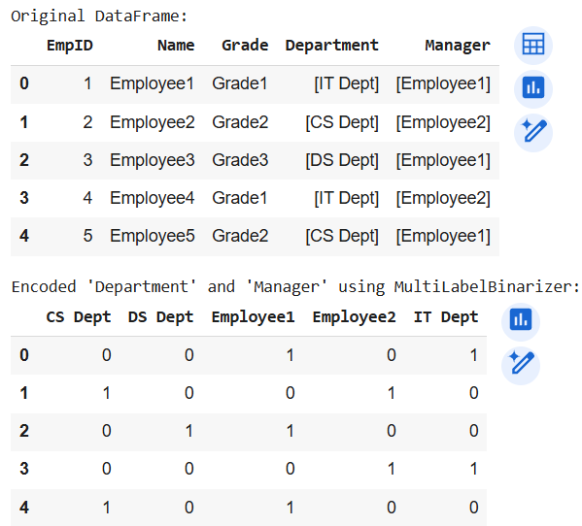

**Encoding Ordinal Categorical Features**

Ex1: Encode the employee’s grade and Level feature of following data using scikit-learn's MultiLabelBinerizer.

EmpID: 1,2,3,4,5

Name: “Employee1”,“Employee2”,“Employee3”,“Employee4”,“Employee5”

Grade: “Grade1”,“Grade2”,“Grade3”,“Grade1”,“Grade2”,

Department: “IT Dept”, “CS Dept”,”DS Dept”,“IT Dept”, “CS Dept”

Level: ”Junior”,”Senior”,”Class1”,”Junior”,”Senior”

import pandas as pd

from sklearn.preprocessing import MultiLabelBinarizer

data = {

'EmpID': [1, 2, 3, 4, 5],

'Name': ["Employee1", "Employee2", "Employee3", "Employee4", "Employee5"],

'Grade': [["Grade1"], ["Grade2"], ["Grade3"], ["Grade1"], ["Grade2"]], # MultiLabelBinarizer expects lists of labels

'Department': [["IT Dept"], ["CS Dept"], ["DS Dept"], ["IT Dept"], ["CS Dept"]],

'Level': [["Junior"], ["Senior"], ["Class1"], ["Junior"], ["Senior"]] # MultiLabelBinarizer expects lists of labels

}

df_ordinal = pd.DataFrame(data)

print("Original DataFrame:")

display(df_ordinal)

# Create MultiLabelBinarizer

mlb = MultiLabelBinarizer()

# Fit and transform the 'Grade' and 'Level' columns

# Combine the lists of labels for MultiLabelBinarizer

combined_ordinal_labels = df_ordinal['Grade'] + df_ordinal['Level']

encoded_ordinal_features = mlb.fit_transform(combined_ordinal_labels)

# Convert the encoded features back to a DataFrame

encoded_df = pd.DataFrame(encoded_ordinal_features, columns=mlb.classes_)

print("\nEncoded 'Grade' and 'Level' using MultiLabelBinarizer:")

display(encoded_df)

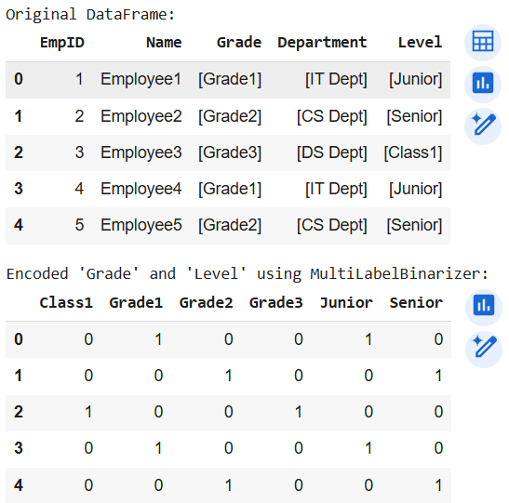

**Encode Dictionaries of Features**

Ex1: Encode the following Dictionaries of features and display the features and feature names.

{“Red”:122, “Green”:130,”Blue”:100}

{“Green”:135,”Blue”:200}

{“Red”:132, “Green”:230,”Blue”:100}

{“Red”:152,”Blue”:150}

{“Red”:162, “Green”:140,”Blue”:200}

from sklearn.feature_extraction import DictVectorizer

data_dict = [

{"Red": 122, "Green": 130, "Blue": 100},

{"Green": 135, "Blue": 200},

{"Red": 132, "Green": 230, "Blue": 100},

{"Red": 152, "Blue": 150},

{"Red": 162, "Green": 140, "Blue": 200}

]

# Create DictVectorizer and Set sparse=False to get a dense NumPy array

dict_vectorizer = DictVectorizer(sparse=False)

# Encode dictionaries

encoded_data = dict_vectorizer.fit_transform(data_dict)

# Display features and feature names

print("Encoded Features:")

display(encoded_data)

print("\nFeature Names:")

display(dict_vectorizer.get_feature_names_out())

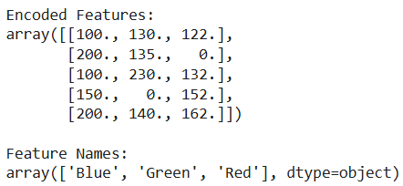

**Imputing Missing Class Values**

Ex1: Input the categorical values of the given dataset using the SimpleImputer class using 'most_frequent' or 'constant' strategy

Reference code

import pandas as pd

df = pd.DataFrame([["BSc", "IT"],

[np.nan, "IT"],

["BSc", np.nan],

["BCom", "CS"]], dtype="category")

imp = SimpleImputer(strategy="most_frequent")

print(imp.fit_transform(df))

import pandas as pd

import numpy as np

from sklearn.impute import SimpleImputer

# Create DataFrame with missing categorical values

df = pd.DataFrame([["BSc", "IT"],

[np.nan, "IT"],

["BSc", np.nan],

["BCom", "CS"]], dtype="category")

print("Original DataFrame:")

display(df)

# Create SimpleImputer with 'most_frequent' strategy

imputer_most_frequent = SimpleImputer(strategy="most_frequent")

# Impute missing values

imputed_data_most_frequent = imputer_most_frequent.fit_transform(df)

print("\nDataFrame after imputing with 'most_frequent' strategy:")

display(imputed_data_most_frequent)

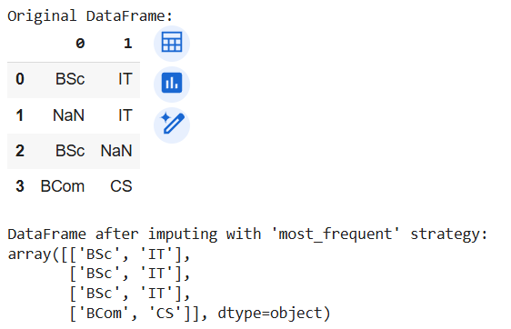

#### **C. Textual Data Handling**

**Cleaning Text**

Q. 1. Copy the data from the Placement Cell page of RJ College website and clean the text. Also replace the short forms in the text.

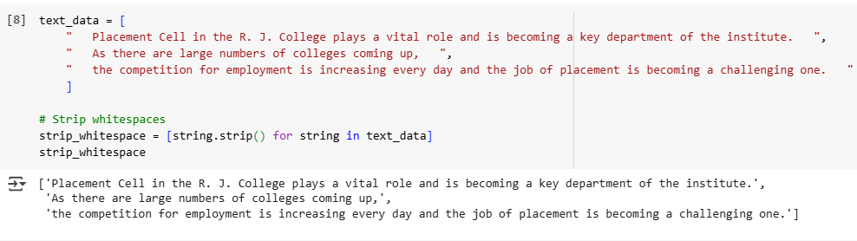

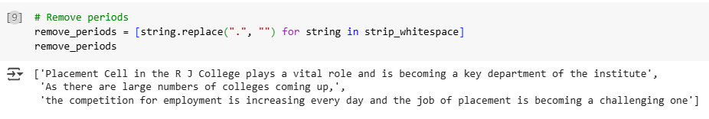

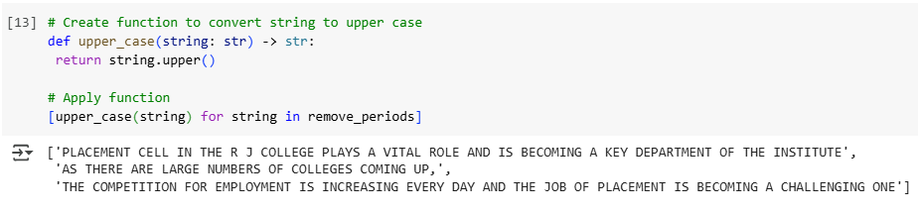

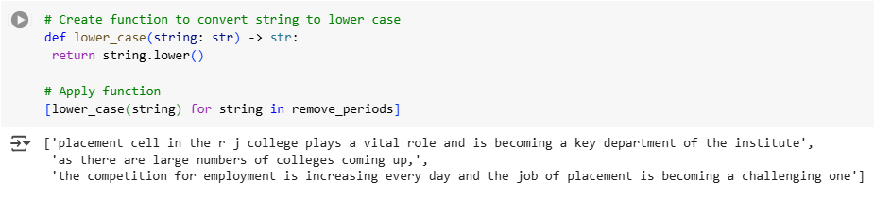

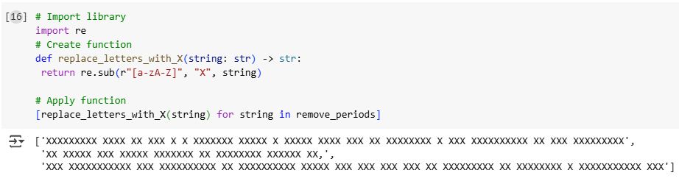

**Parsing and Cleaning HTML**

Q. 2. Get the HTML data of About Us Page of R J College Website with the help of web scraping process and extract the details of contact.

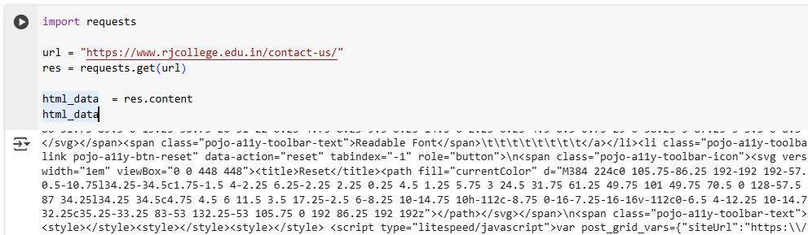

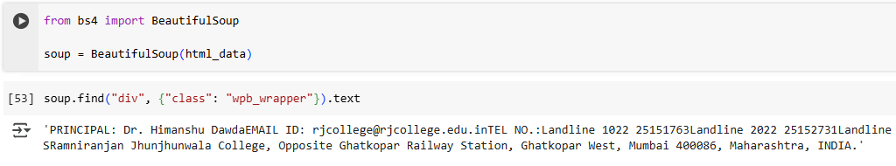

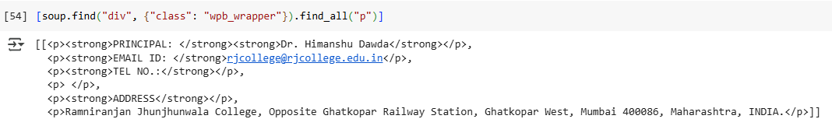

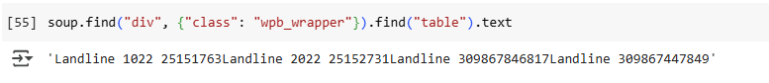

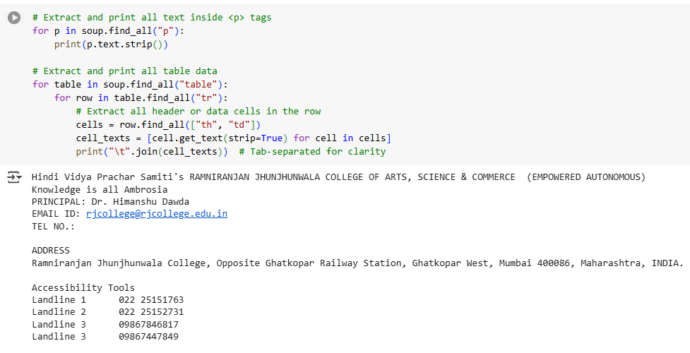

Q. 3. Demonstrate or perform the following operations on the admissions data on the IT department page of RJ College.

1. Extract data of admissions in simple text format

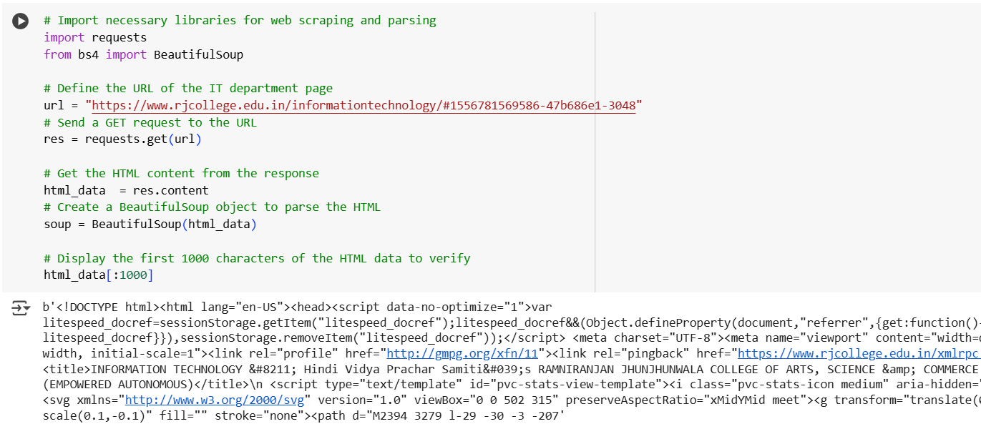

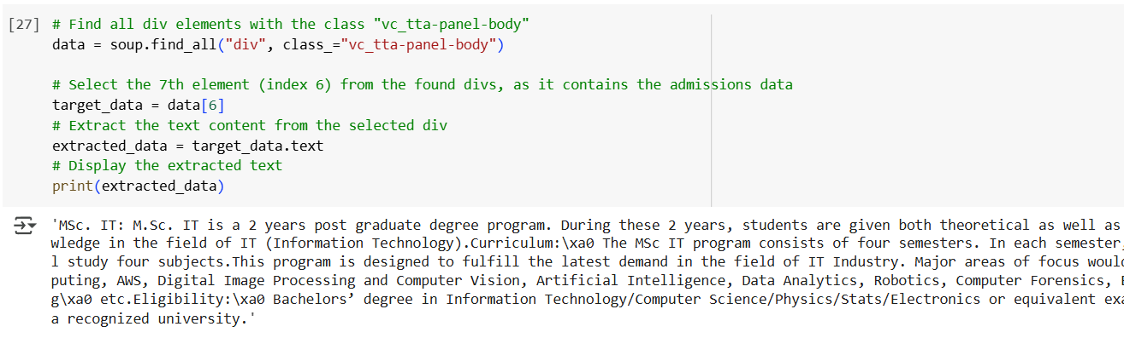

1. Clean data.

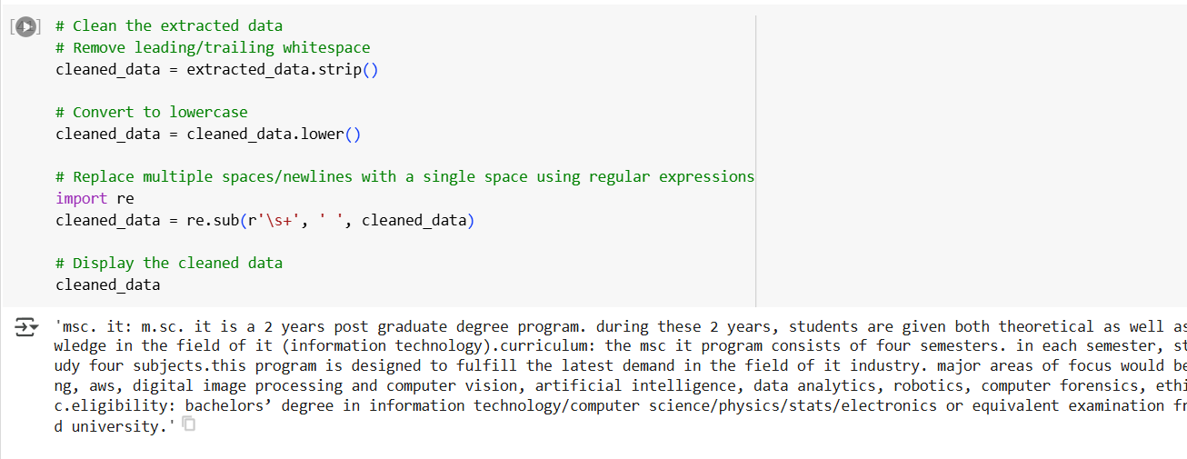

1. Remove all punctuations.

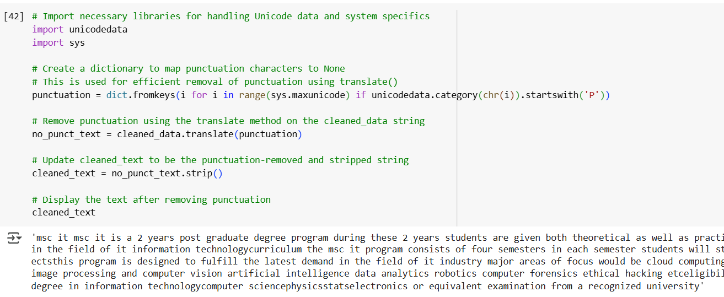

1. Tokenize text and remove all stop words.

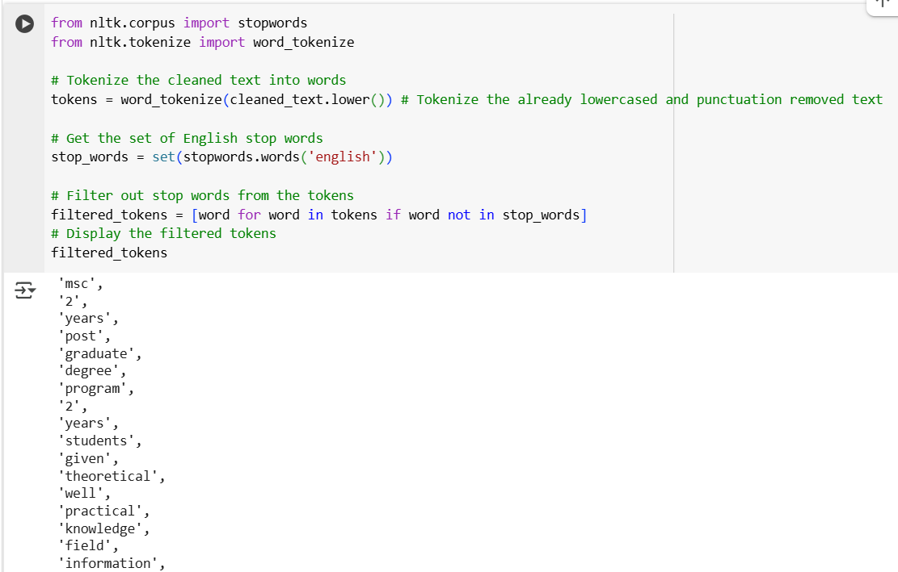

1. Stemming words.

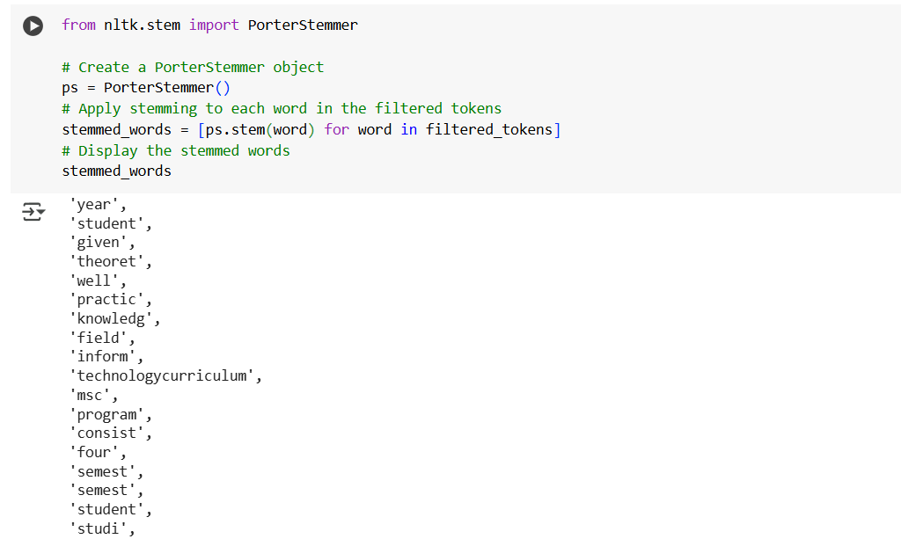

1. Display Part of speech tagging of each word.

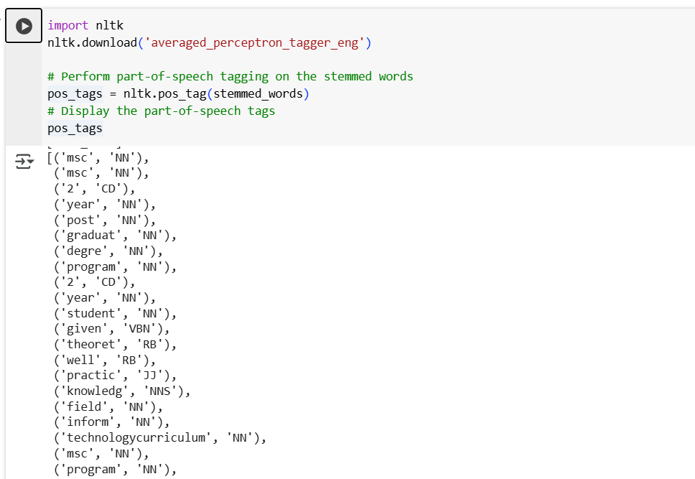

#### **D. Date Time Data Handling**

Q. Store the following data into a dataframe and display the datewise, timewise temperature and humidity as per the Indian and US date and time.

Given Data:

High & Low Weather Summary for the Past Weeks

|  |  |  |  |
| --- | --- | --- | --- |
|  | Temperature | Humidity | Pressure |
| High | 31 °C (18 Jul, 14:30) | 96% (20 Jul, 17:30) | 1006 mbar (20 Jul, 17:30) |
| Low | 25 °C (23 Jul, 05:30) | 74% (18 Jul, 14:30) | 998 mbar (25 Jul, 05:30) |
| Average | 28 °C | 88% | 1003 mbar |

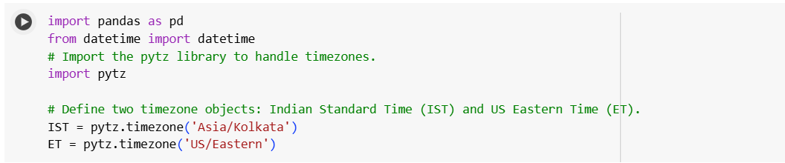

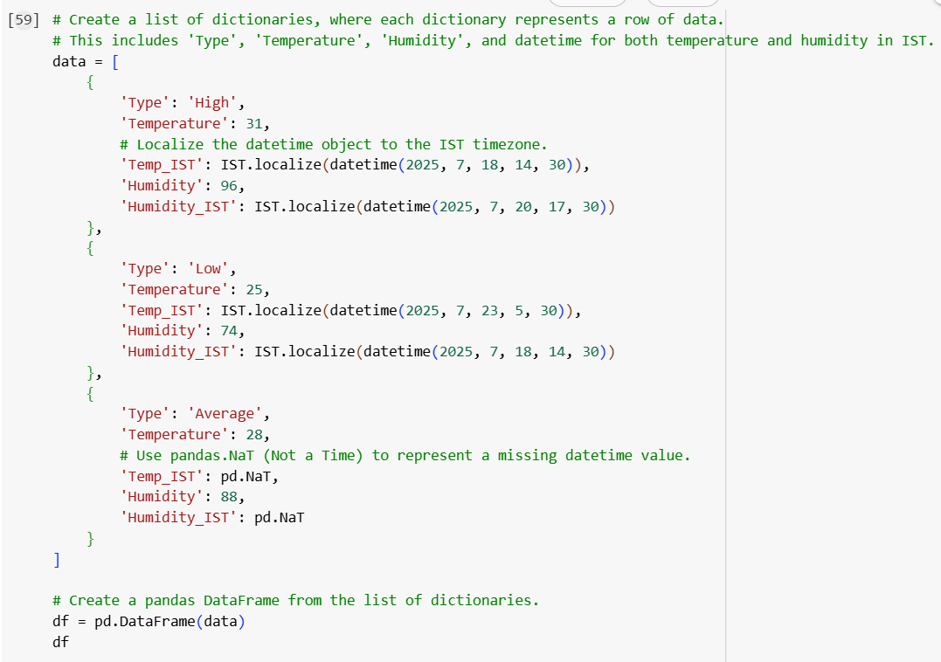

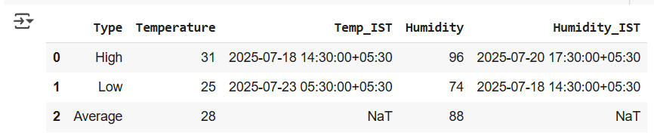

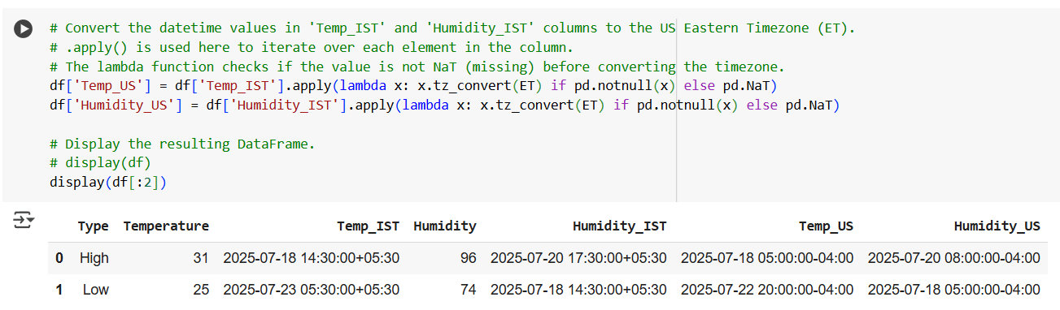

**Colab file link:**  [Prac_2.ipynb](https://colab.research.google.com/drive/1S0k3SLkKfZfTNk_e7KOzYxupraBK7M4e#scrollTo=jbztKL1gpXhO)

### **Practical 3: Linear Regression**

Aug 4, 2025

#### A. Fitting a Linear Relationship and Multiple linear regression

1. Simple Linear Relationship

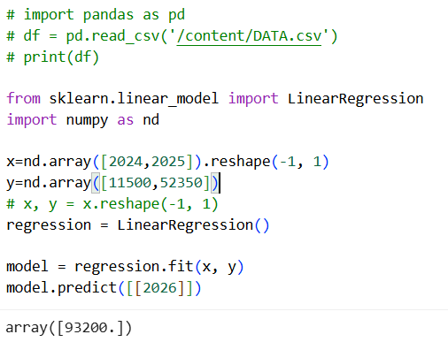

1. Linear Relationship with graph plotting

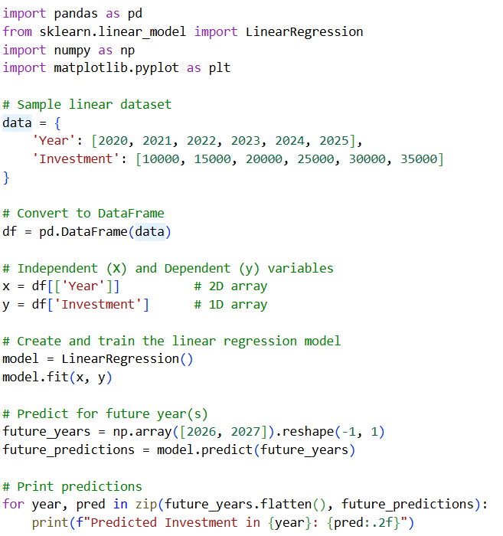

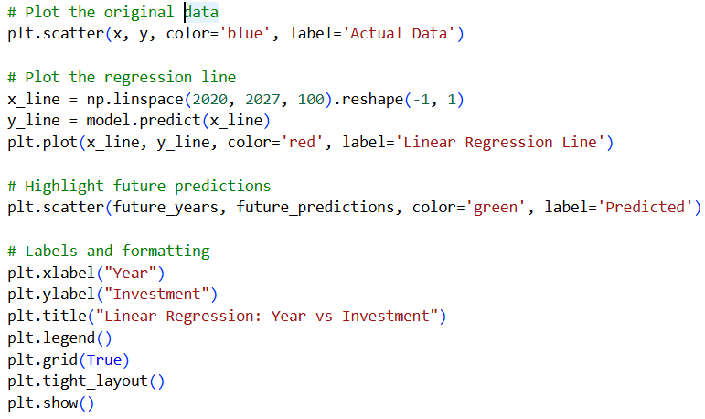

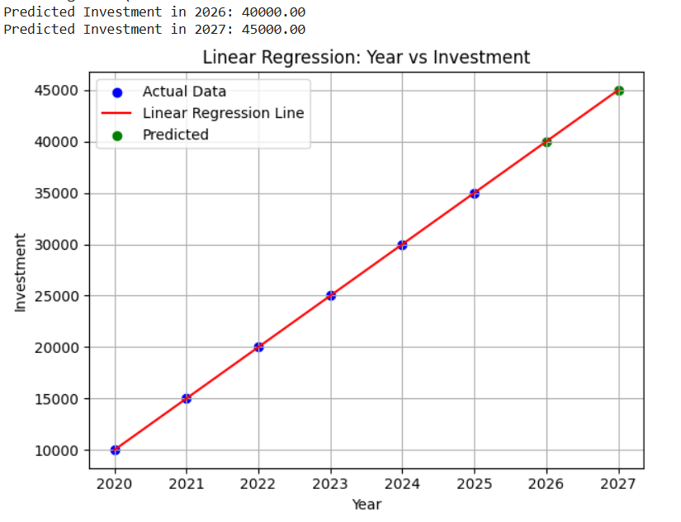

#### B. Fitting a Nonlinear Relationship

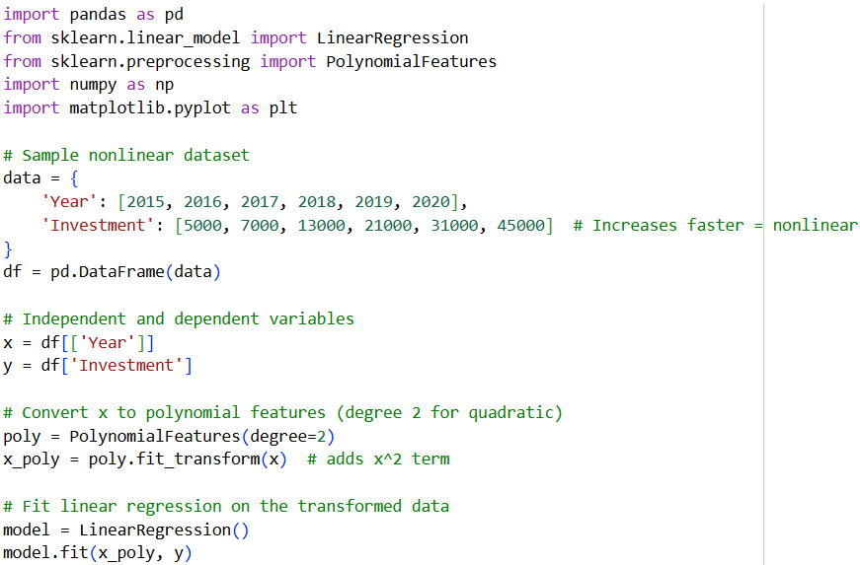

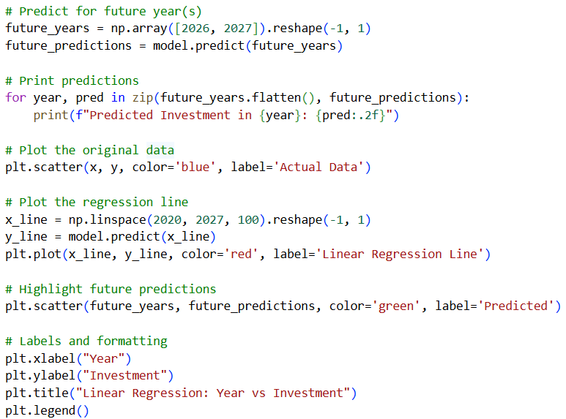

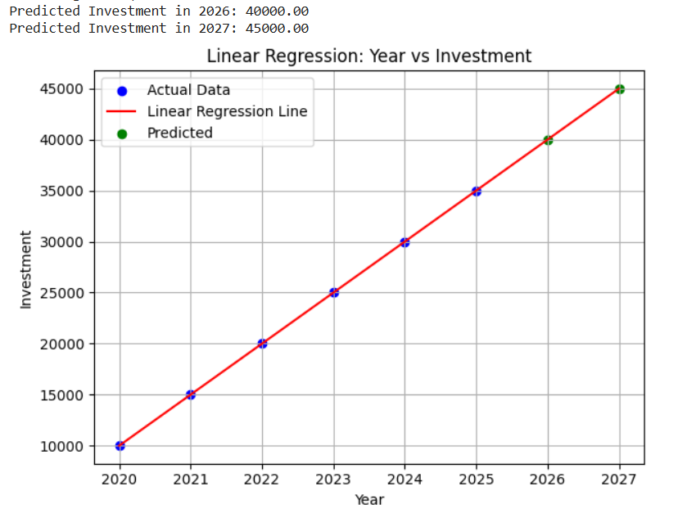

#### C. Reducing Variance with Regularization

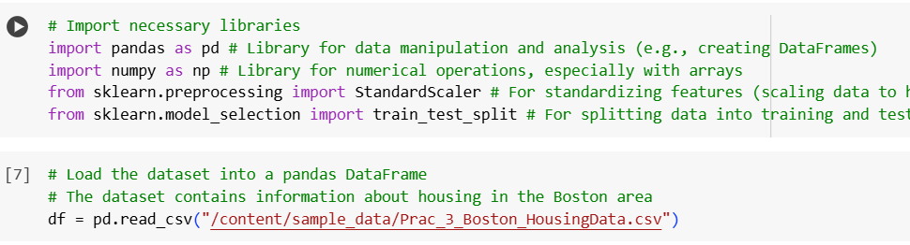

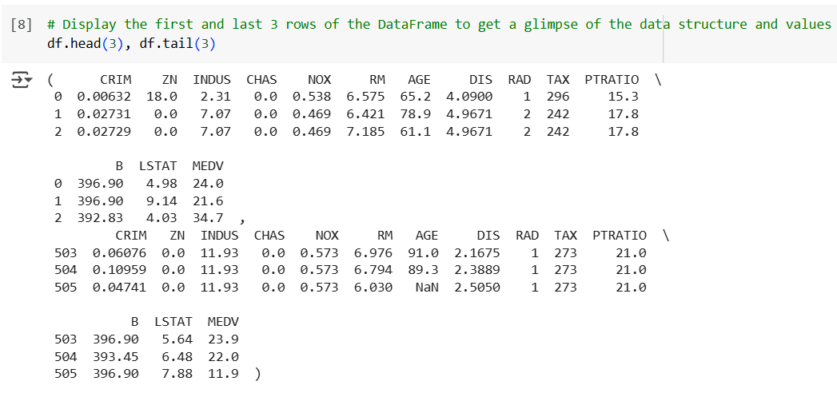

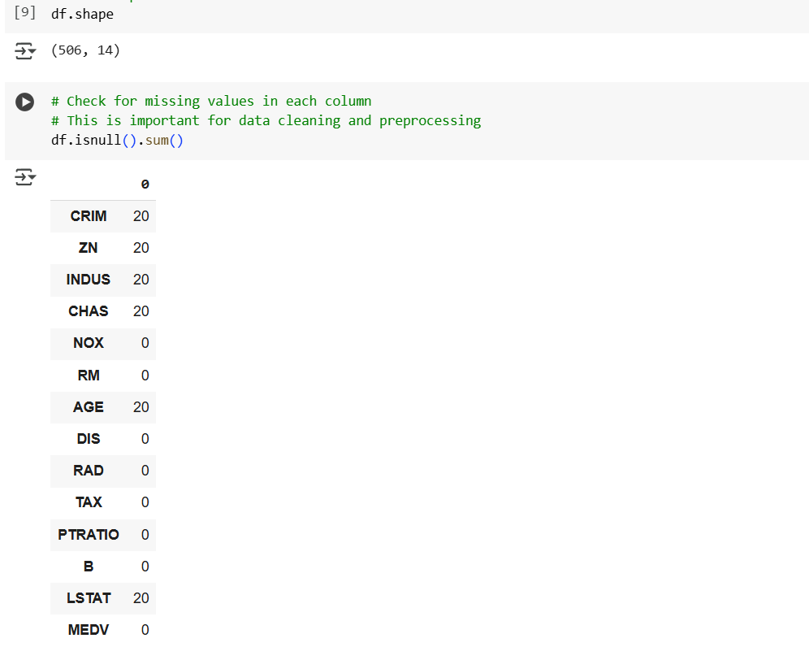

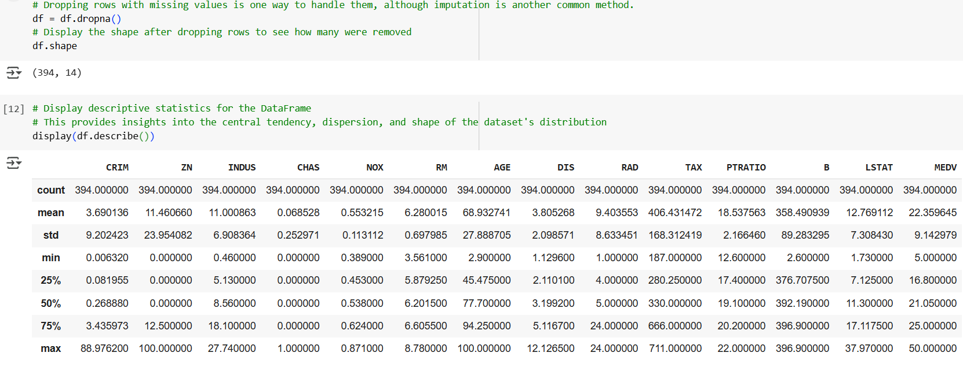

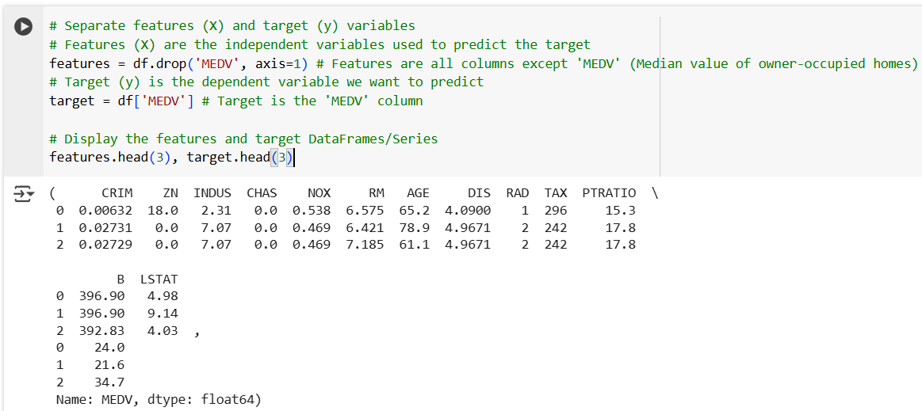

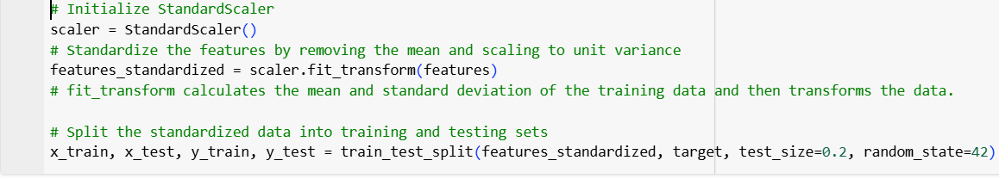

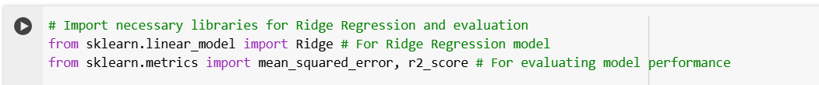

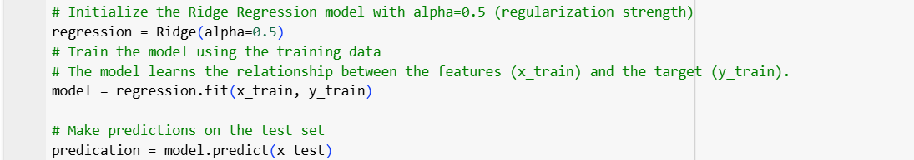

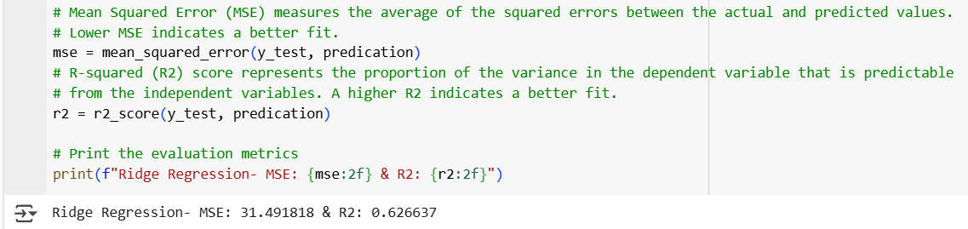

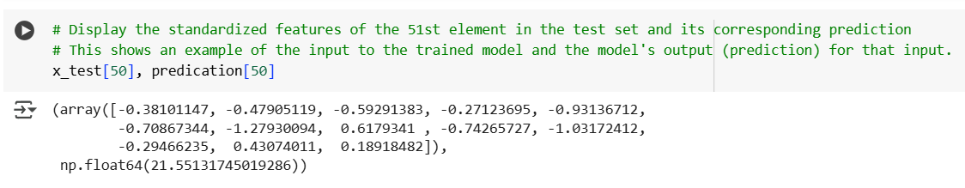

#### D. Reducing Features with Lasso Regression.



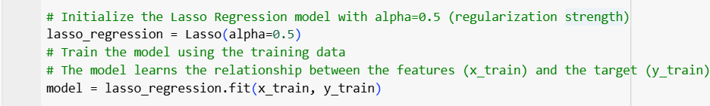

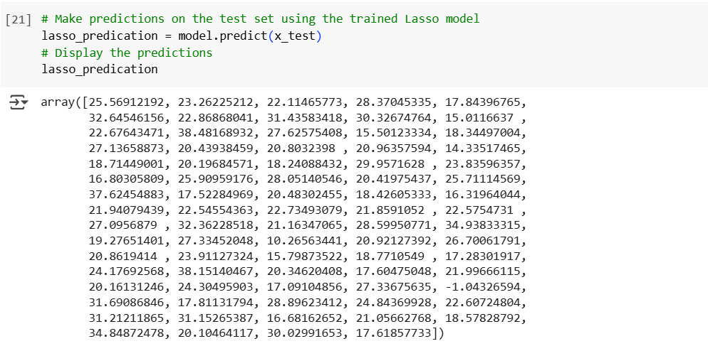

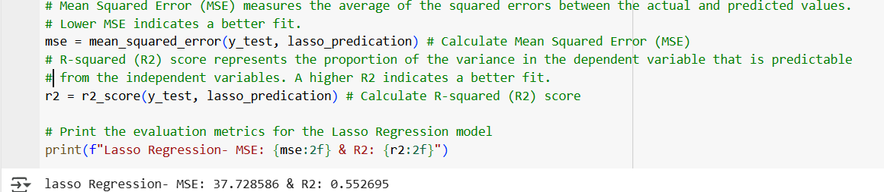

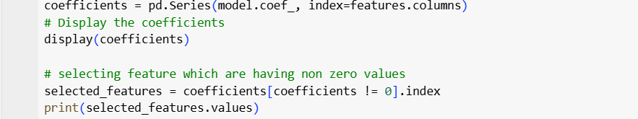

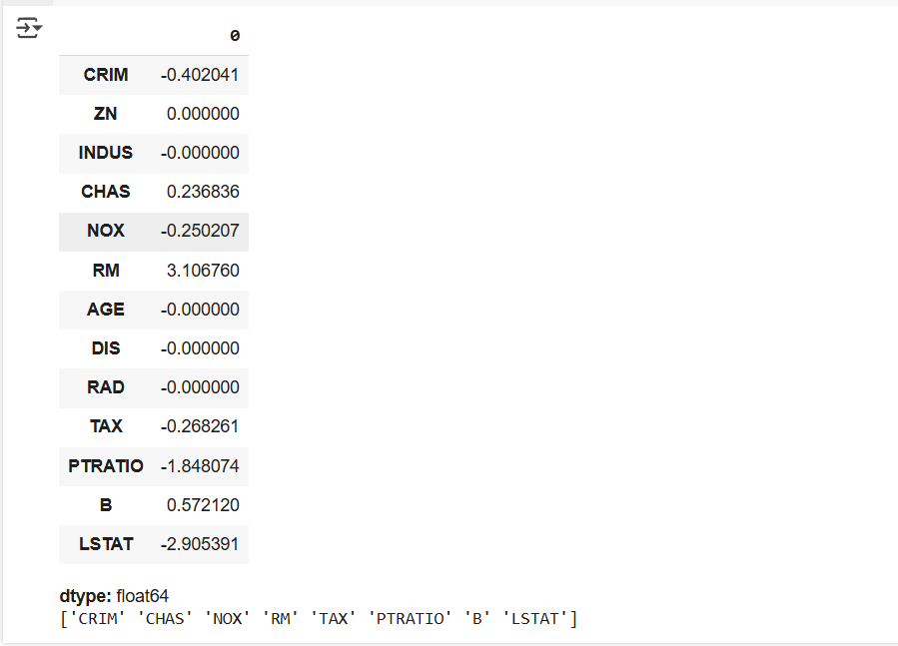

#### E. Least Square Regression algorithm



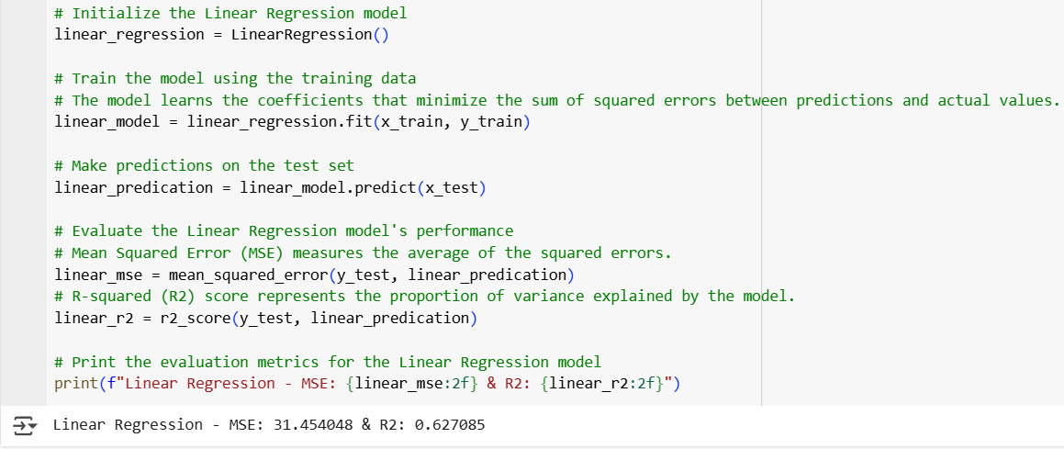

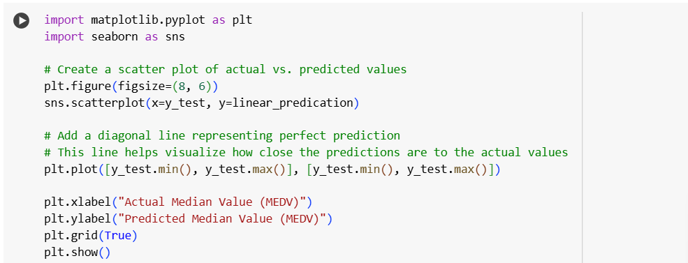

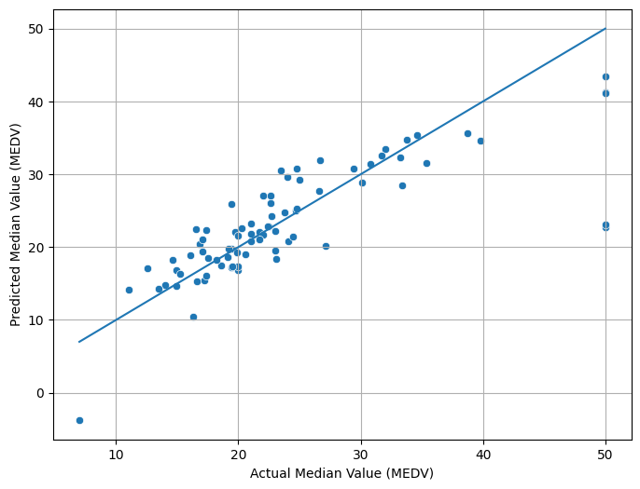

Colba file link: [Prac_3.ipynb](https://colab.research.google.com/drive/1qLli5Q4LwUwzhWmHENNKT8QyJlz2oLbD)

### **Practical 4: Trees and Forests**

Aug 11, 2025

**Explain decision tree classifier and decision tree regressor algorithms with the method that is used to split data into tree branches.**

**Decision Tree Classifier**

A Decision Tree Classifier is a supervised learning algorithm used for classification tasks. It splits the data into subsets based on feature values, creating a tree-like structure where each internal node represents a decision based on a feature, and each leaf node represents a class label.

**Method of Splitting Data (Classification):**

To split data, the Decision Tree Classifier uses Gini Impurity or Information Gain (based

on entropy) as criteria to measure the "purity" of a node. It chooses the feature and threshold

that best splits the data by reducing impurity or maximizing information gain.

* Gini Impurity: Measures how often a randomly chosen element would be incorrectly classified if randomly labeled based on the distribution of class labels in the node.
* Information Gain: Measures the reduction in entropy after a split. Entropy represents the randomness in the data.

**Evaluation Methods for Decision Tree Classifier:**

1. Accuracy: Percentage of correct predictions.
2. Precision, Recall, F1-Score: Useful for imbalanced datasets.
3. Confusion Matrix: Shows true positives, true negatives, false positives, and false negatives.
4. ROC-AUC: Evaluates the tradeoff between true positive rate and false positive rate for different threshold values.

**Decision Tree Regressor**

A Decision Tree Regressor is a similar algorithm used for regression tasks. Instead of

classifying, it predicts a continuous value by learning decision rules from data.

**Method of Splitting Data (Regression):**

The Decision Tree Regressor splits data by minimizing the Mean Squared Error (MSE) or

Mean Absolute Error (MAE) between predicted and actual values. The algorithm selects

splits that minimize the sum of squared residuals or the absolute difference between predicted

and actual values.

**Evaluation Methods for Decision Tree Regressor:**

1. Mean Squared Error (MSE): Measures the average squared difference between actual and predicted values.
2. Mean Absolute Error (MAE): Measures the average absolute difference between actual and predicted values.
3. R-squared (R2): Indicates the proportion of variance in the target variable that is explained by the model.
4. Root Mean Squared Error (RMSE): Square root of the MSE, easier to interpret in the context of the problem.

**Explain Random Forest Classifier and Random Forest Regressor with the method that is used to split data into tree branches.**

**Random Forest Classifier**

A Random Forest Classifier is an ensemble learning method that constructs multiple

decision trees and aggregates their predictions (majority voting for classification) to produce

a final result. The random forest adds randomness by selecting random subsets of features for

each tree to improve generalization and reduce overfitting.

**Method of Splitting Data (Classification):**

Each decision tree in the random forest uses Gini Impurity or Information Gain, just like in a

single decision tree. However, random feature selection at each split ensures that different

trees focus on different aspects of the data, improving robustness.

**Evaluation Methods for Random Forest Classifier:**

1. Accuracy: Overall percentage of correct predictions.
2. Precision, Recall, F1-Score: Helpful in imbalanced datasets.
3. Confusion Matrix: For evaluating classification performance.
4. Out-of-Bag (OOB) Score: In random forests, samples not used to train a tree can be used to evaluate it, providing a cross-validated performance estimate.

**Random Forest Regressor**

A Random Forest Regressor is similar to a Random Forest Classifier but used for regression

tasks. It builds multiple decision trees, and the final prediction is the average of all trees'

predictions.

**Method of Splitting Data (Regression):**

Similar to the Decision Tree Regressor, random forests for regression minimize MSE or

MAE at each split. Additionally, randomness is introduced by selecting random features and

random samples for each tree.

**Evaluation Methods for Random Forest Regressor:**

1. Mean Squared Error (MSE): Measures the average squared error between predicted and actual values.
2. Mean Absolute Error (MAE): Average absolute difference between predicted and actual values.
3. R-squared (R2): Proportion of variance explained by the model.
4. Out-of-Bag (OOB) Error: In regression, OOB error provides a performance estimate based on samples that were not used in training a specific tree.

**Methods of evaluation of random tree algorithms:**

**1. Classification Metrics:**

* Accuracy, Precision, Recall, F1-Score: As with decision trees.
* ROC Curve and AUC: Evaluate the trade-off between true positive rate and false positive rate across different threshold settings.

**2. Regression Metrics:**

* Mean Absolute Error (MAE), Mean Squared Error (MSE), R-squared: As with decision trees.
* Feature Importance: Random forests can also provide insights into the importance of different features for making predictions.

Dataset: [Loan Prediction Problem Dataset](https://www.kaggle.com/datasets/altruistdelhite04/loan-prediction-problem-dataset)

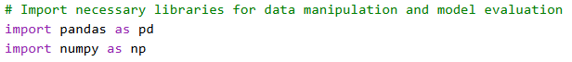

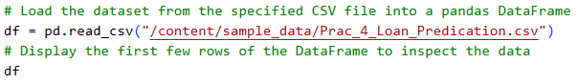

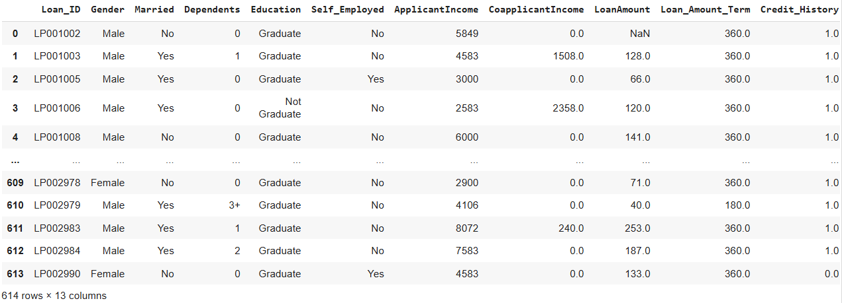

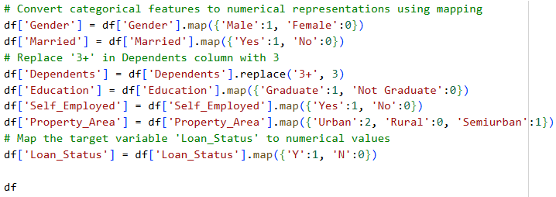

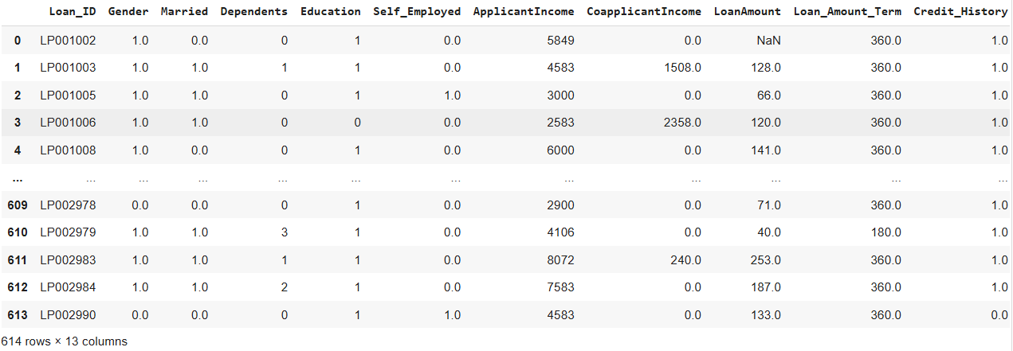

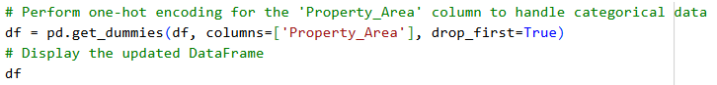

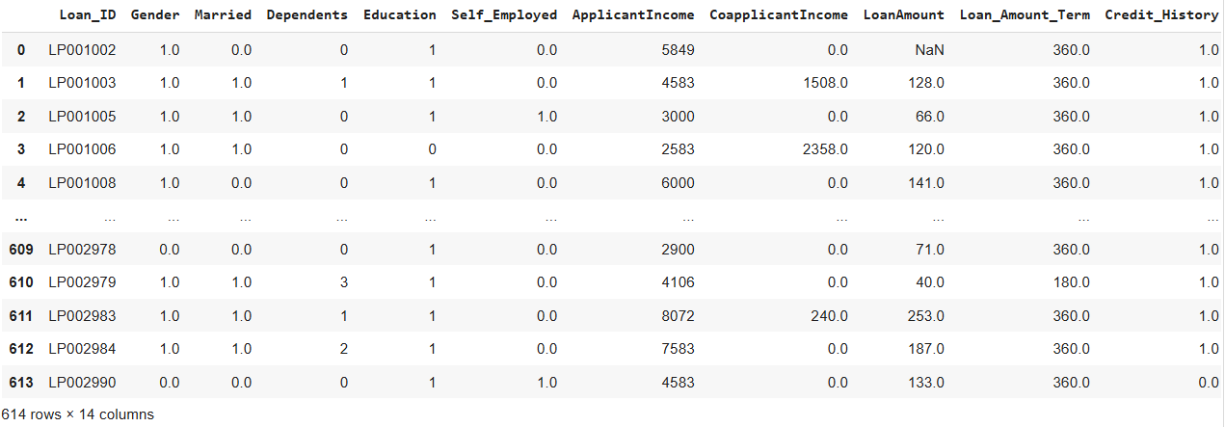



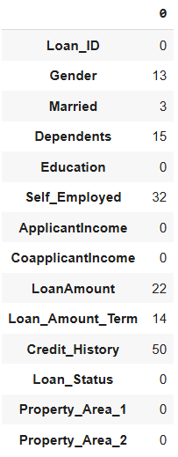

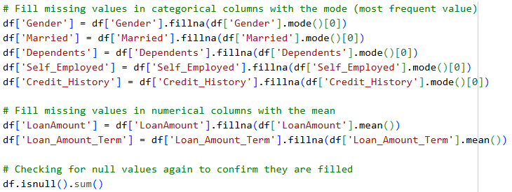

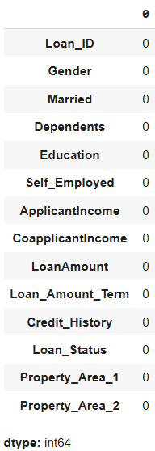

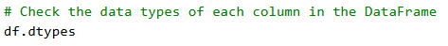

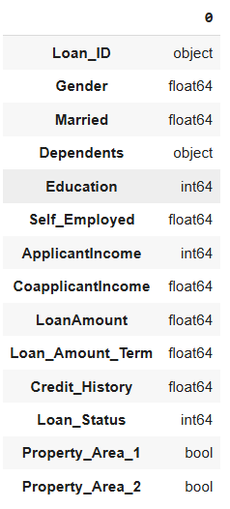

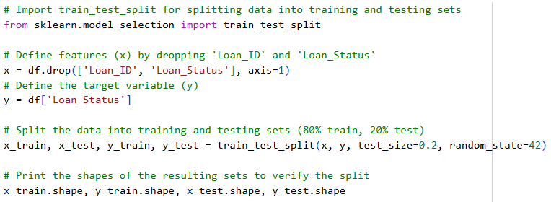



#### 

#### **A. Training a Decision Tree Classifier**

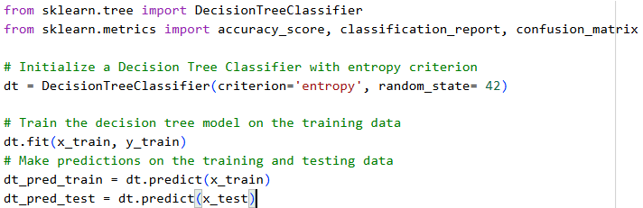

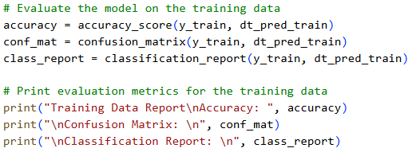

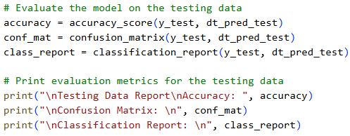

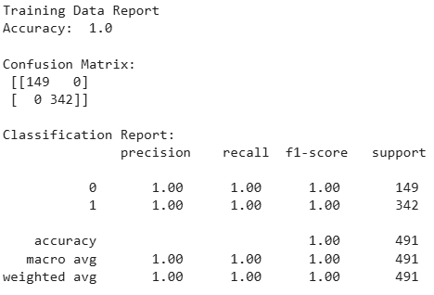

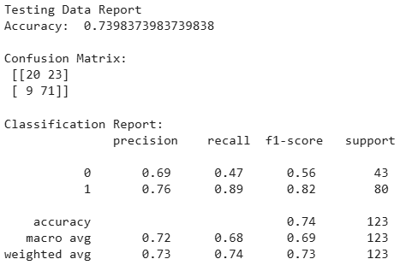

#### **B. Training a Decision Tree Regressor**

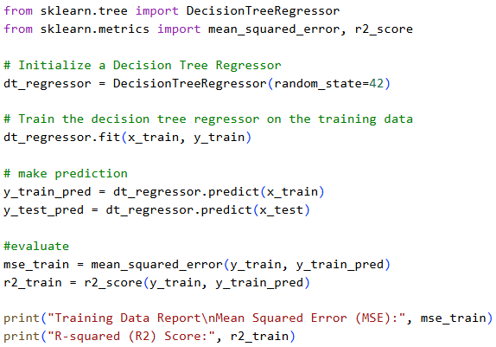

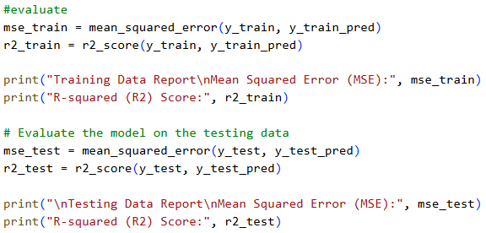

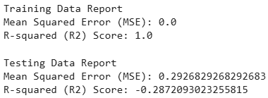

#### **C. Training a Random Forest Classifier**

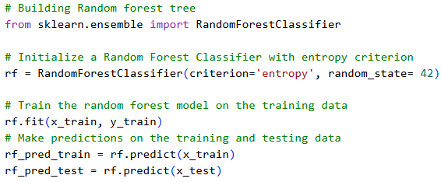

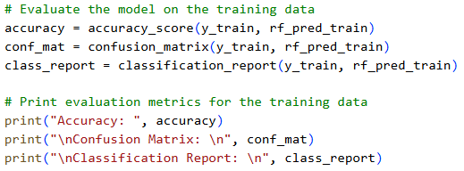

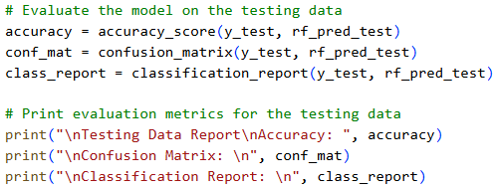

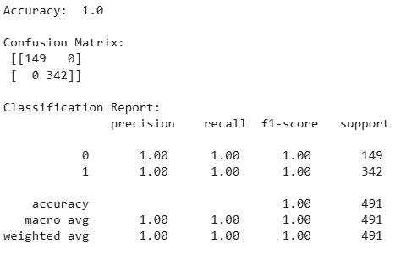

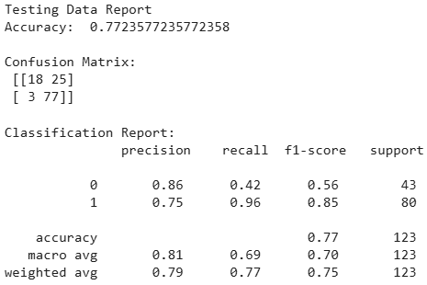

#### 

#### **D. Training a Random Forest Regressor**

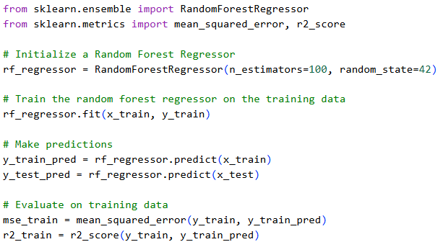

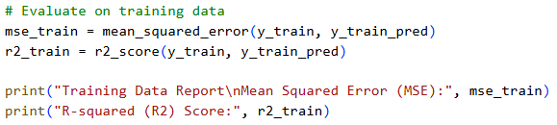

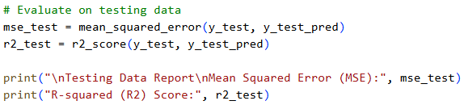

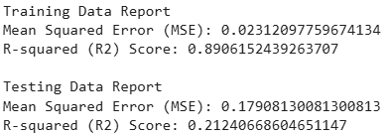

**Colab file link:** [**Prac_4**](https://colab.research.google.com/drive/1mSzUTBVV5MmZAoaOan0ahGLv7w-v3XZy?usp=drive_link)

### **Practical 5: K-Nearest Neighbors Classifier**

Sep 12, 2025

**Explain K-nearest Neighbour classifier with an example. Demonstrate the method of calculation of the center in each iteration.**

**K-Nearest Neighbors (KNN) Classifier**

The K-Nearest Neighbors (KNN) classifier is a supervised learning algorithm used for classification tasks. It works by finding the 'k' closest training examples in the feature space and assigning the most common class label among them to the new data point.

* Step 1: Choose the number 'k', the number of nearest neighbors to consider.
* Step 2: Calculate the distance between the new data point and all the data points in the training set (common distance metrics include Euclidean distance).
* Step 3: Identify the 'k' nearest neighbors to the new data point.
* Step 4: Determine the class label based on the majority class among these 'k' neighbors.

Calculation Example (simplified):

1. Distance Calculation: For each training example, compute the distance from the new data point.
2. Neighbor Selection: Sort the training examples by distance and select the top 'k' nearest ones.
3. Voting: Count the number of votes for each class among these 'k' neighbors.
4. Classification: Assign the class label with the most votes to the new data point.

**K-Means Algorithm**

Theory: K-Means is an unsupervised learning algorithm used for clustering. It partitions a

dataset into 'k' clusters by iteratively improving the placement of cluster centers.

1. Initialization: Choose 'k' initial cluster centers randomly.
2. Assignment Step: Assign each data point to the nearest cluster center.
3. Update Step: Recalculate the cluster centers as the mean of all data points assigned to each cluster.
4. Repeat: Iterate the assignment and update steps until cluster centers no longer change significantly.

**Evaluation Methods:**

1. Within-Cluster Sum of Squares (WCSS): Measures the variance within each cluster. Lower WCSS indicates better clustering.
2. Silhouette Score: Measures how similar a data point is to its own cluster compared to other clusters. Scores range from -1 to 1, with higher values indicating better clustering.
3. Davies-Bouldin Index: Evaluates the average similarity ratio of each cluster with its most similar cluster. Lower values indicate better clustering.

**Explain Radius-Based Nearest Neighbor Classifier**

Theory: The Radius-Based Nearest Neighbor Classifier classifies a data point based on the

class of its neighbors within a specified radius.

* Step 1: Define a radius within which to search for neighbors.
* Step 2: For each new data point, find all training examples within this radius.
* Step 3: Assign the most frequent class label among these neighbors to the new data point.

|  |  |  |  |  |  |  |
| --- | --- | --- | --- | --- | --- | --- |
| Features | | Target |  | Features | | Target |
| X1 | Y1 |  |  | X2 | Y2 |  |
| Brightness | Saturation | Class |  | Brightness | Saturation | Class |
| 40 | 20 | Red |  | 20 | 35 | ? |
| 50 | 50 | Blue |  | 55 | 60 | ? |
| 60 | 90 | Blue |  | 62 | 90 | ? |
| 10 | 25 | Red |  |  |  |  |
| 70 | 70 | Blue |  |  |  |  |
| 60 | 10 | Red |  |  |  |  |
| 25 | 80 | Blue |  |  |  |  |

#### A. Implement the various distance calculation methods

1. **Euclidean Distance:** The Euclidean Distance between two points in Euclidean space is the length of the line segment connecting them. It's calculated using the Pythagorean theorem.
2. **Manhattan Distance (Taxicab or City Block):** The Manhattan Distance is the sum of the absolute differences of their Cartesian coordinates. It's called Manhattan distance because it reflects the real-world distances one would have to walk in a city laid out in a grid.
3. **Minkowski Distance:** The Minkowski Distance is a generalized form of both the Euclidean and Manhattan distances. It's calculated as the p-th root of the sum of the absolute differences raised to the power p.

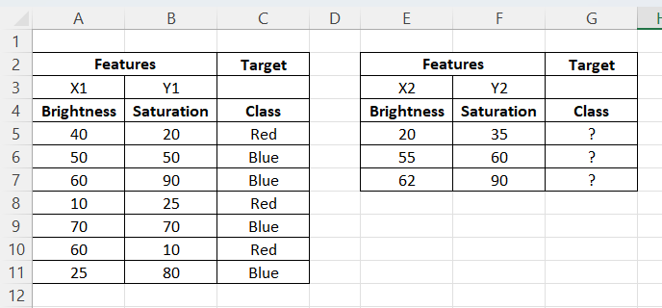

Euclidean =SQRT(POWER(A5-20, 2) + POWER(B5-35, 2))

Manhattan =ABS(A5-20)+ABS(B5-35)

Minkowski (p=3) =((ABS(A5 - 20)^3 + ABS(B5 - 35)^3))^(1/3)

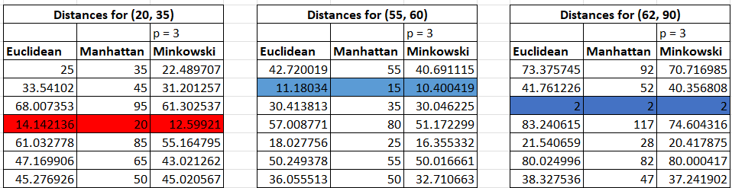

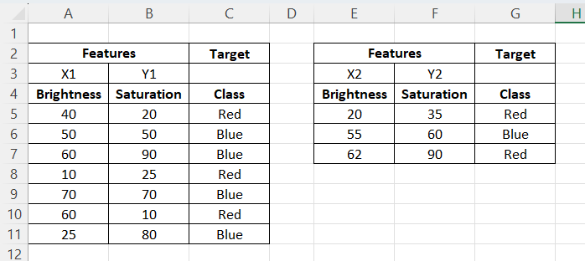

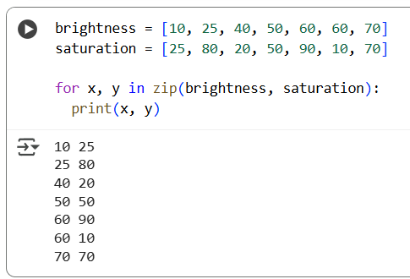

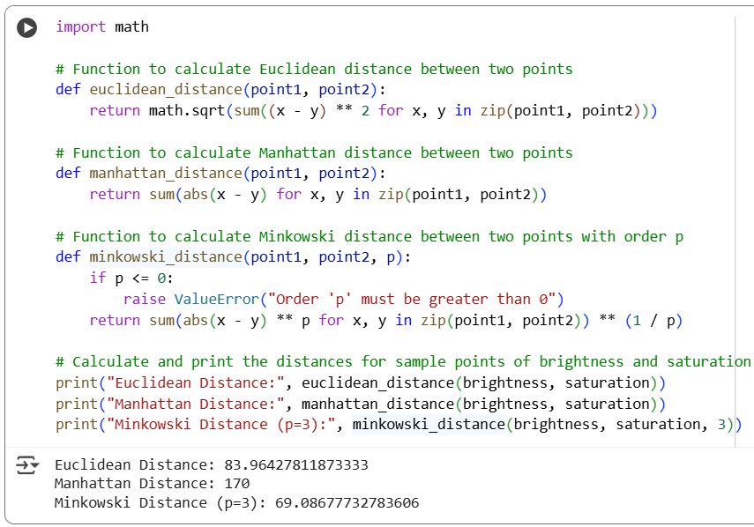

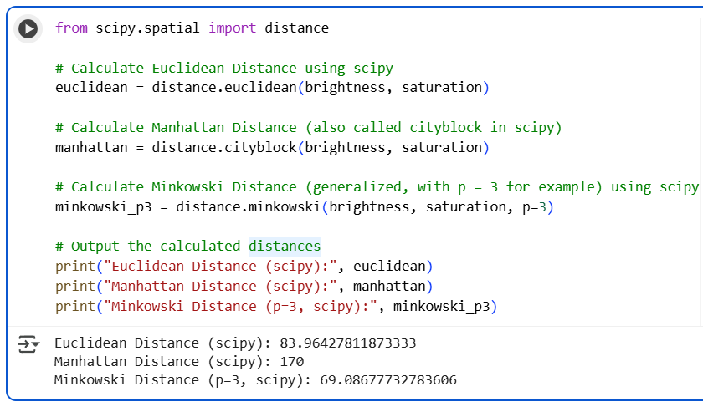

#### B. Creating a Nearest Neighbor Classifier using Euclidean distance method

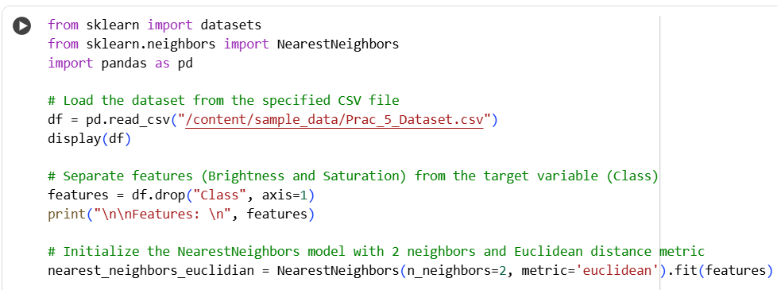

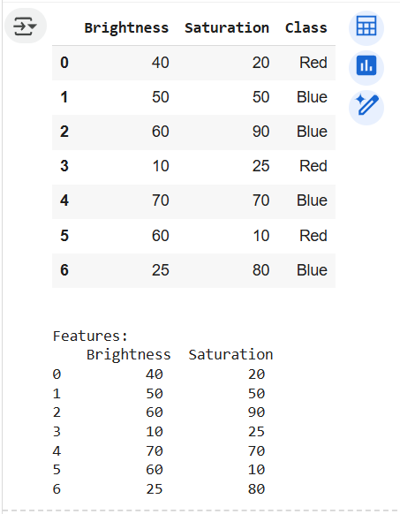

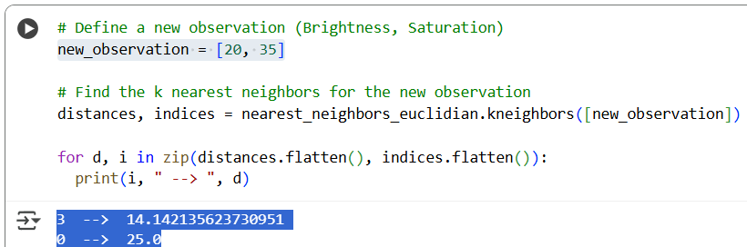

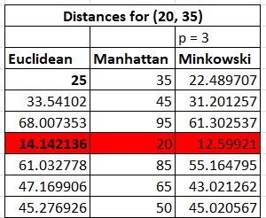

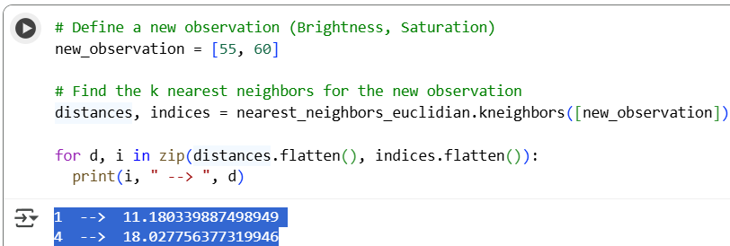

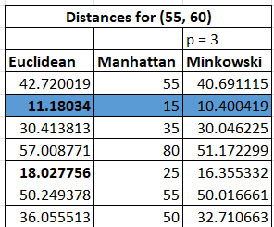

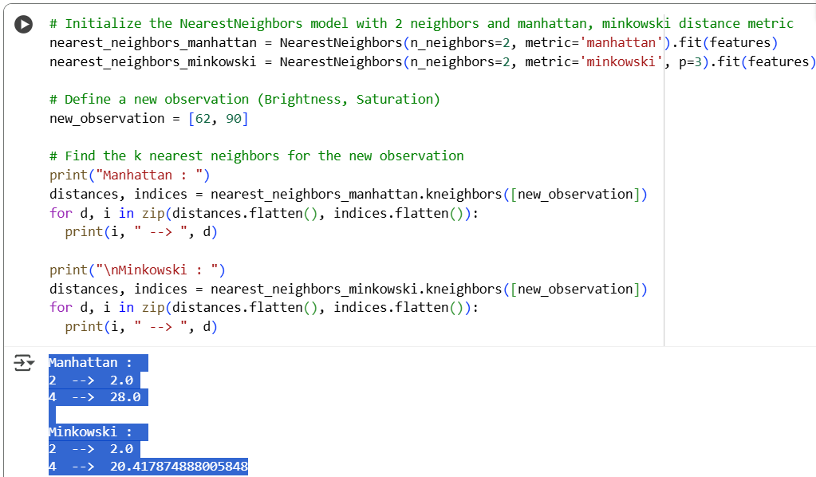

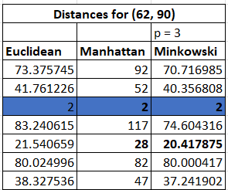

#### C. Creating a Radius-Based Nearest Neighbor Classifier.

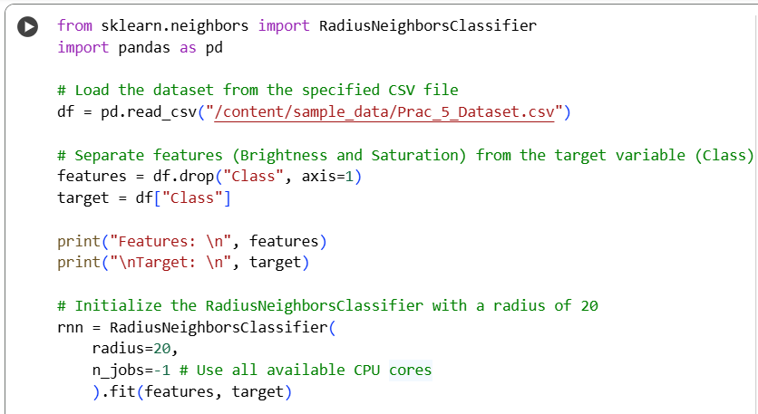

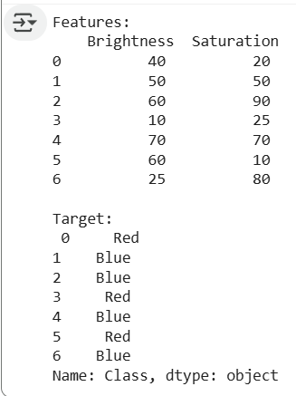

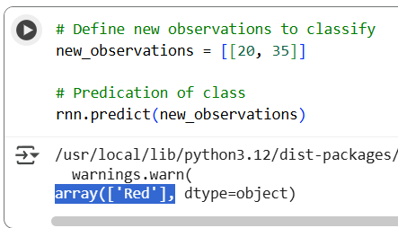

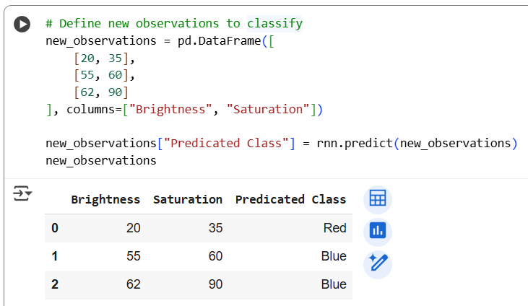

Extra

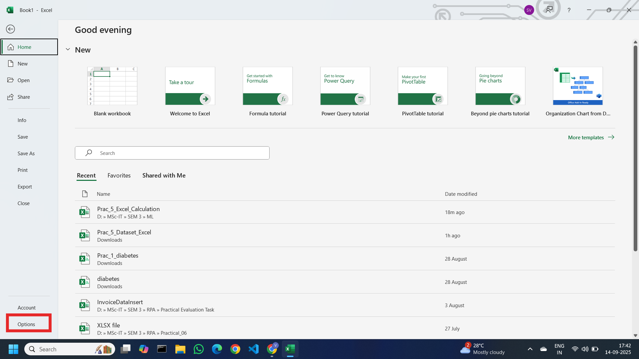

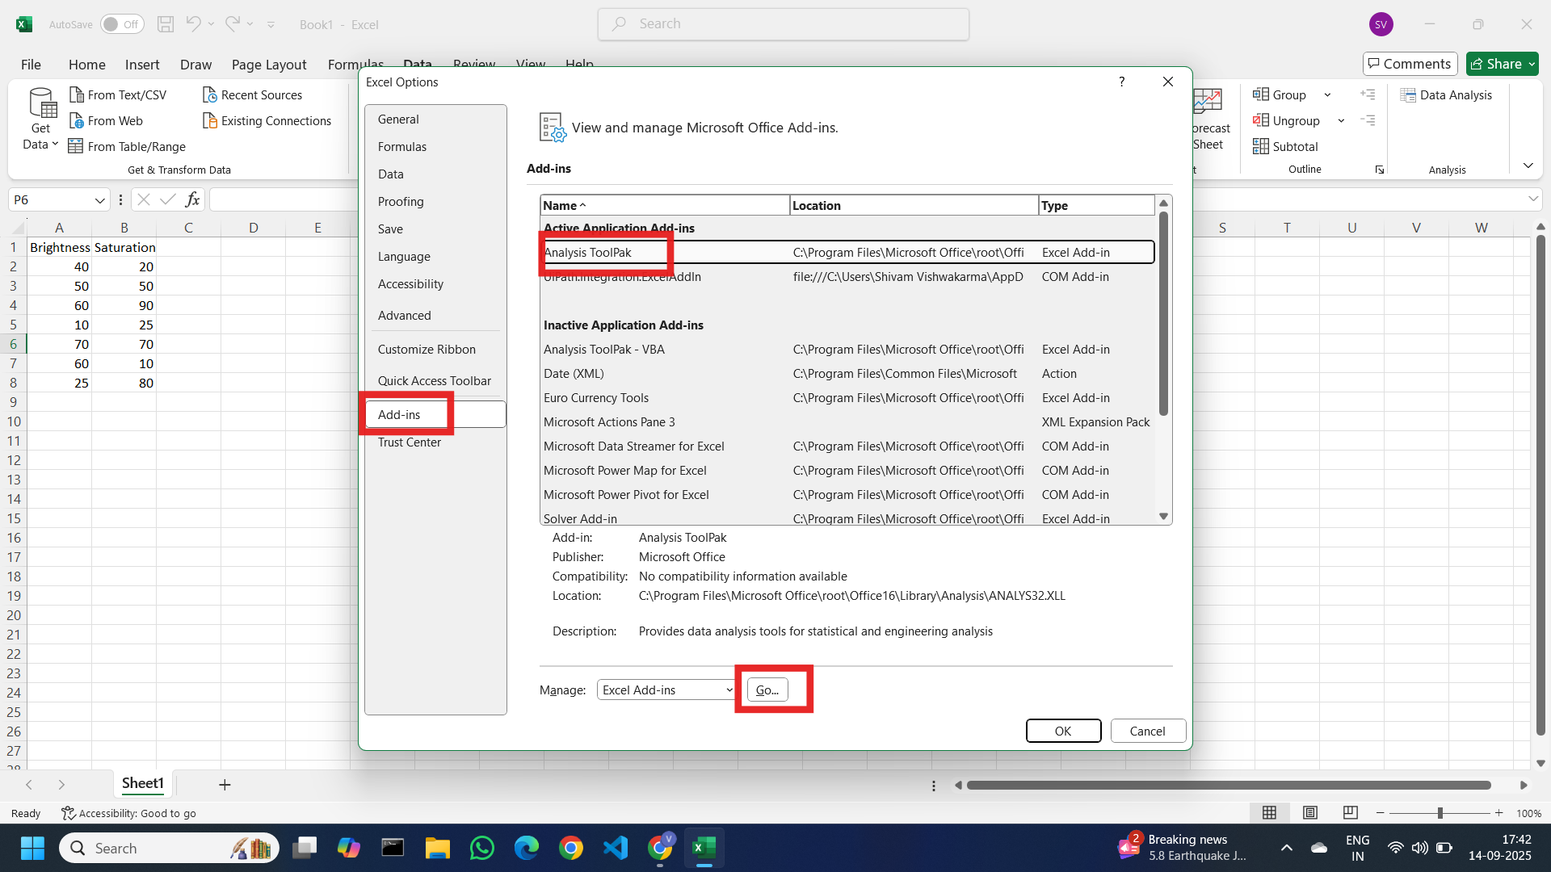

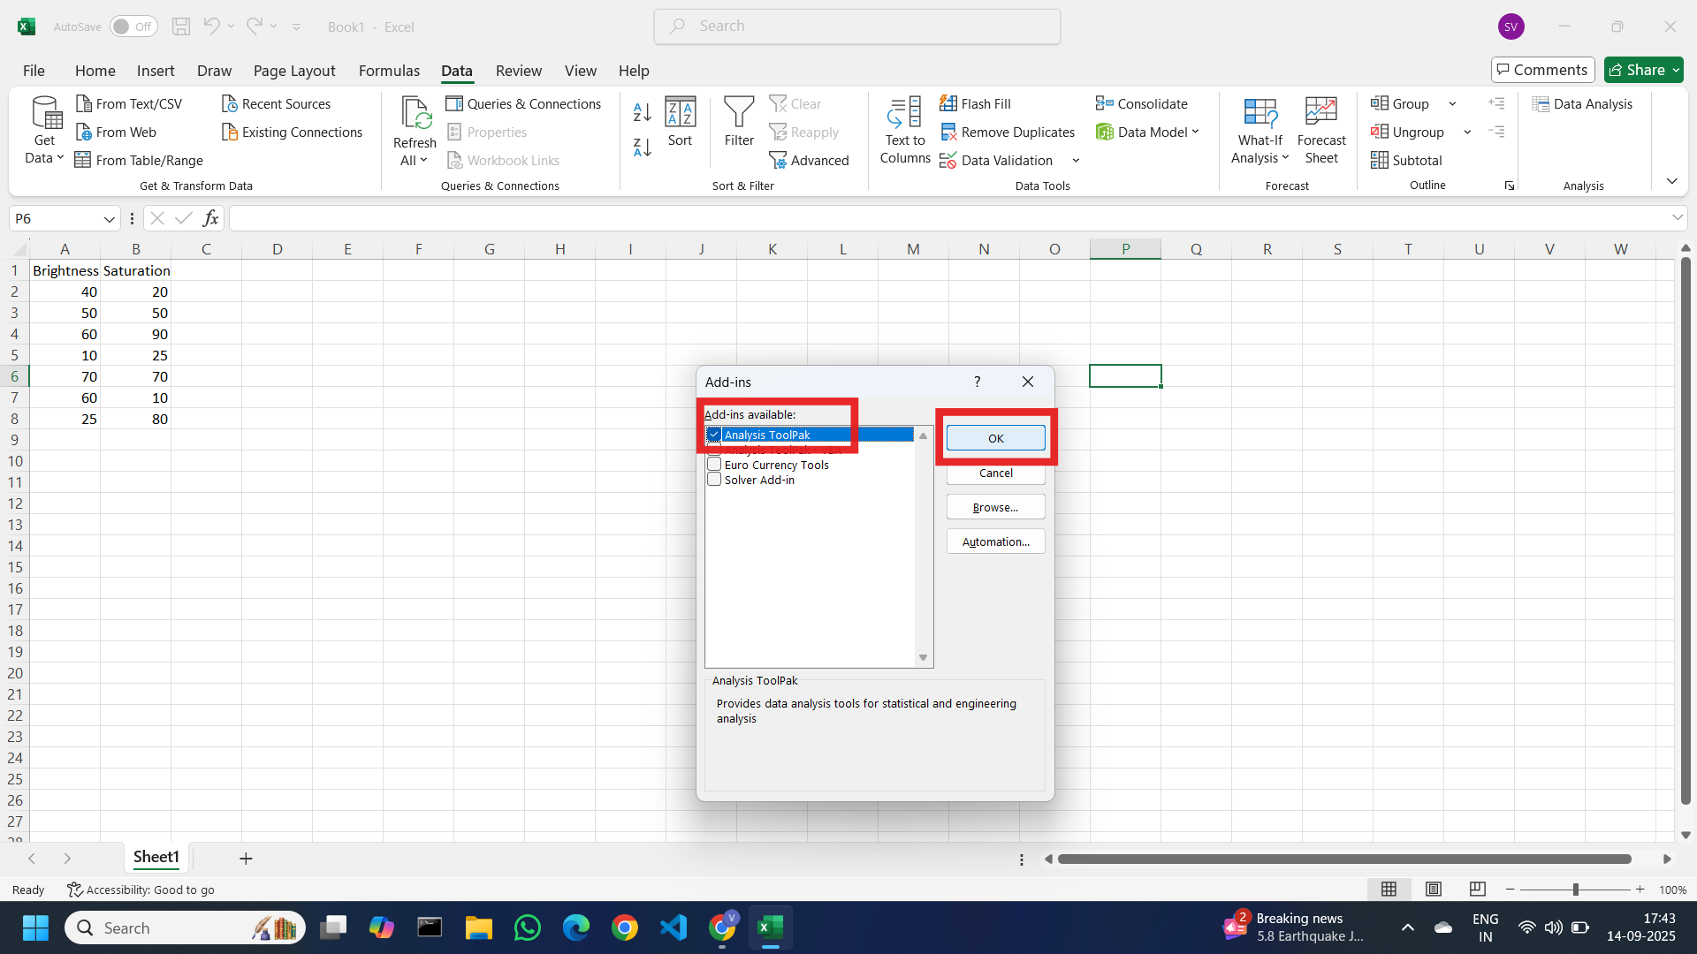

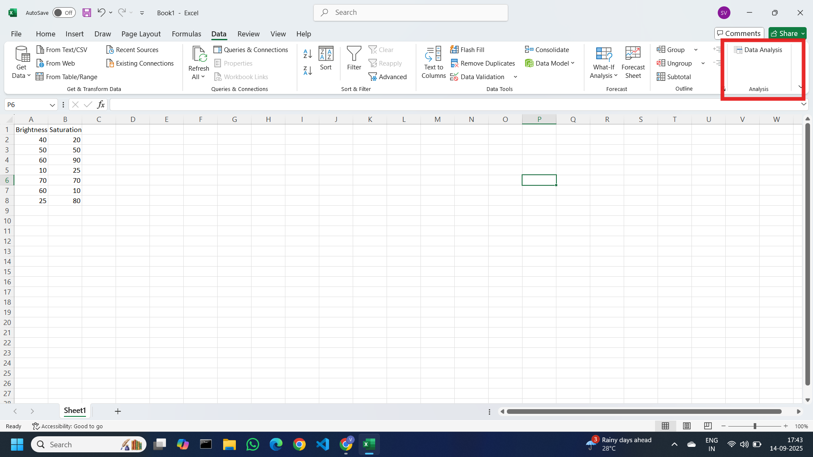

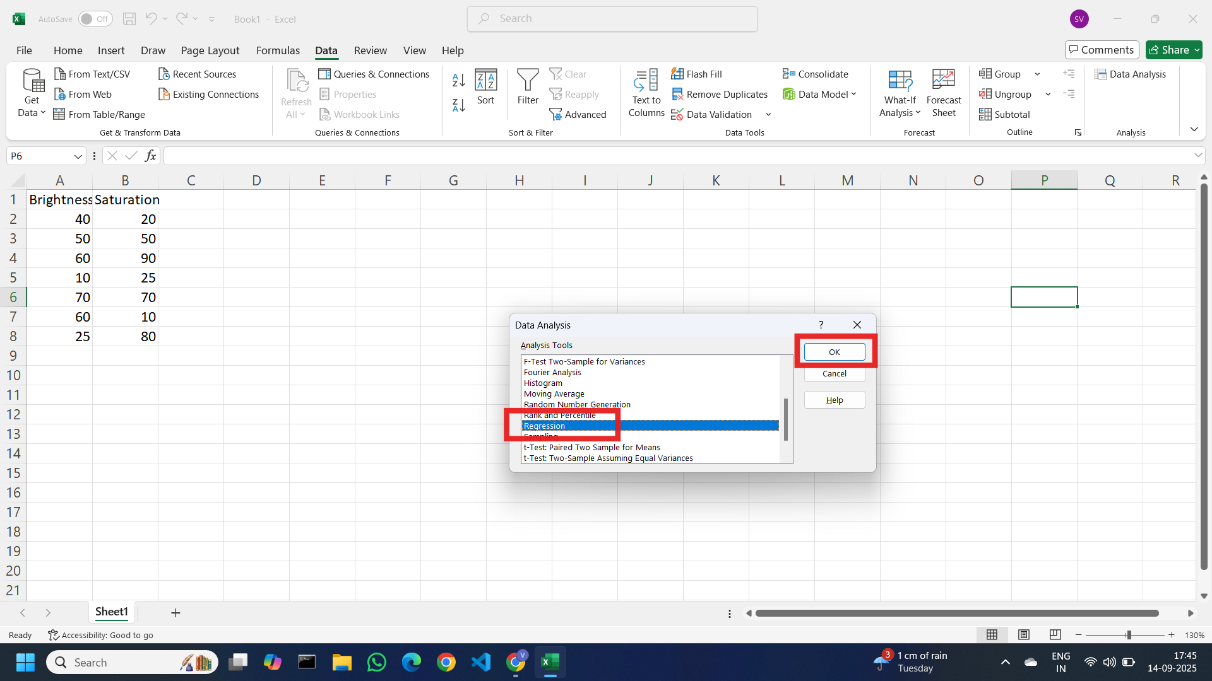

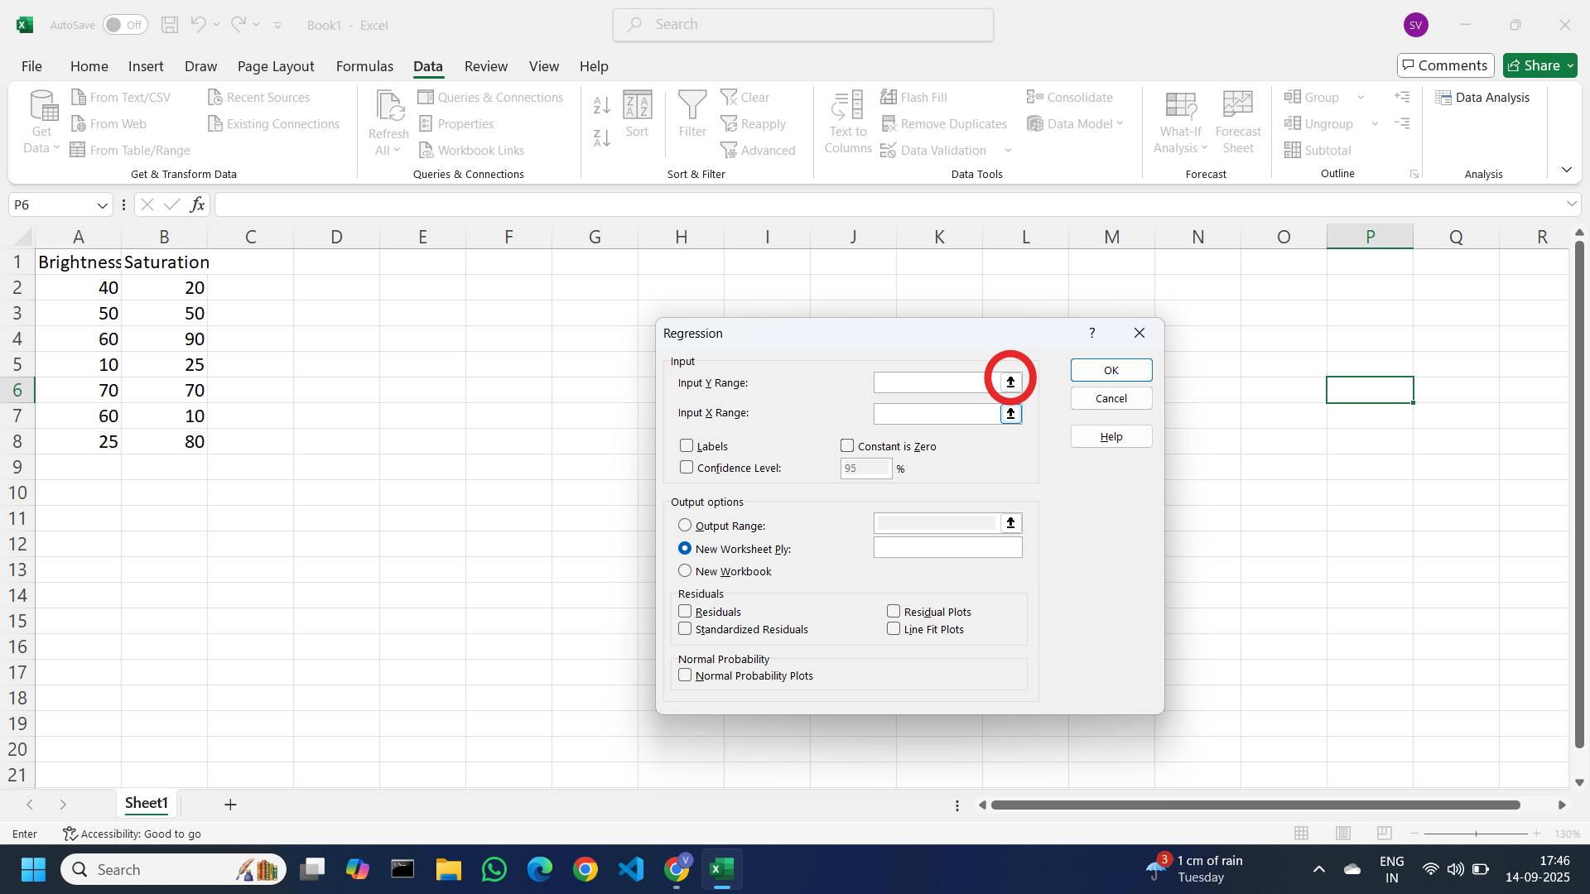

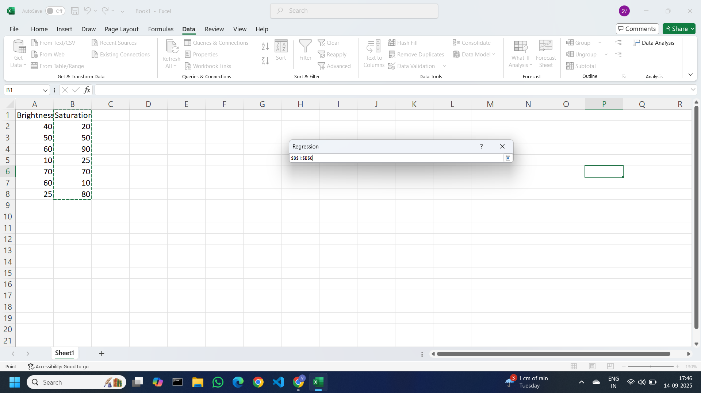

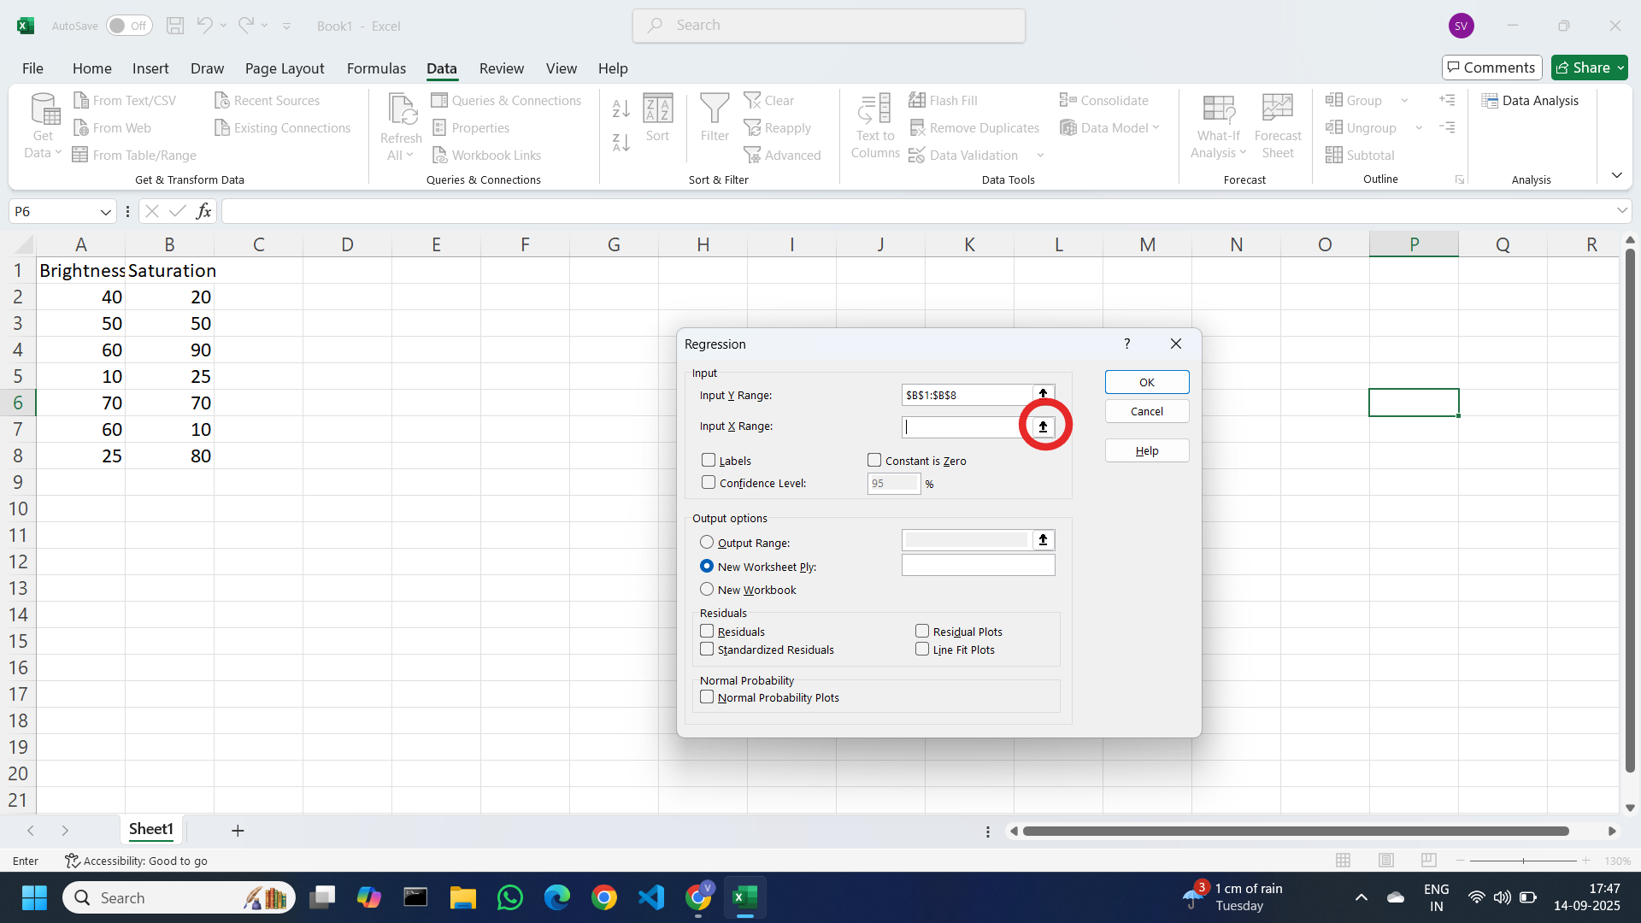

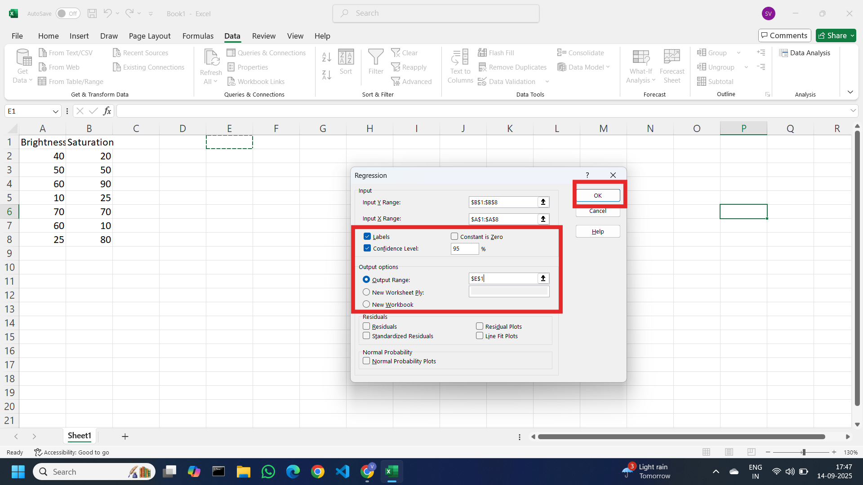

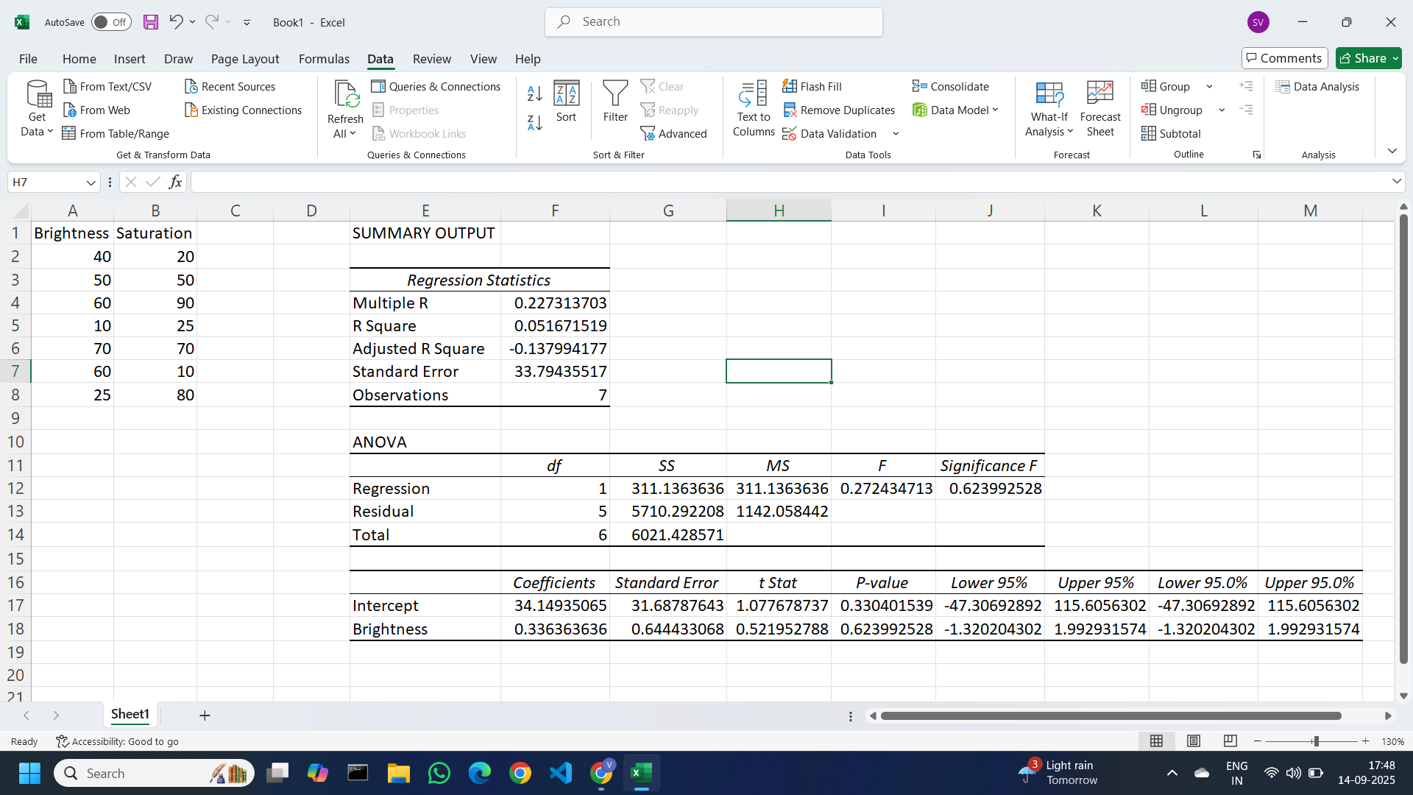

Excel Calculation [Prac_5_Excel_Calculation.xlsx](https://docs.google.com/spreadsheets/d/1fe5sRZmVq7hbZsK7bHnfJ_CHavHyJbLh/edit?usp=drive_link&ouid=106011563062589671609&rtpof=true&sd=true)

Colab file link: [Prac_5.ipynb](https://colab.research.google.com/drive/1qYtXkbpGjCGmMBDXHiQ54AVf5gGUo4uB?usp=drive_link)

### **Practical 6: Logistic Regression**

Sep 18, 2025

**Logistic Regression** is a statistical algorithm used for binary classification tasks. It predicts

the probability that a given input belongs to one of two classes. Despite its name, it is actually

a classification algorithm, not a regression algorithm.

**How Logistic Regression Works:**

1. Linear Combination of Inputs: Logistic Regression computes a weighted sum of the input features (like in Linear Regression). Each feature has a coefficient (or weight) that defines its importance in predicting the target outcome.
2. Sigmoid Function: To convert this linear combination into a probability value (between 0 and 1), the output is passed through the sigmoid function
3. Decision Boundary: Logistic Regression sets a threshold (usually 0.5) to decide the class label. If the output probability is greater than or equal to 0.5, the prediction is classified as 1 (positive class), otherwise 0 (negative class).
4. Cost Function: Instead of using Mean Squared Error (like in Linear Regression), Logistic Regression uses a special cost function called log-loss or binary cross-entropy to measure how well the model predicts probabilities
5. Optimization: The model coefficients are optimized using gradient descent, which minimizes the cost function by iteratively adjusting the weights to reduce prediction errors.

**Key Points:**

* Logistic Regression is good for binary classification problems.
* The output is a probability value, interpreted as the likelihood of the input belonging to a certain class.
* The algorithm is simple, interpretable, and performs well with linearly separable

#### 

#### A. Training a Binary Classifier

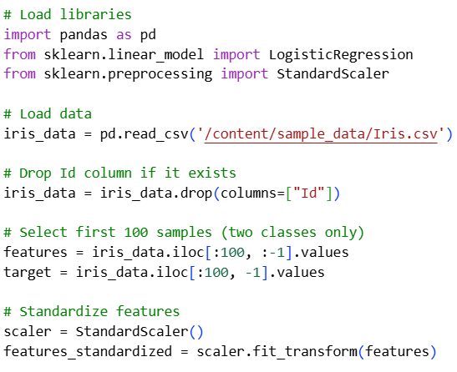

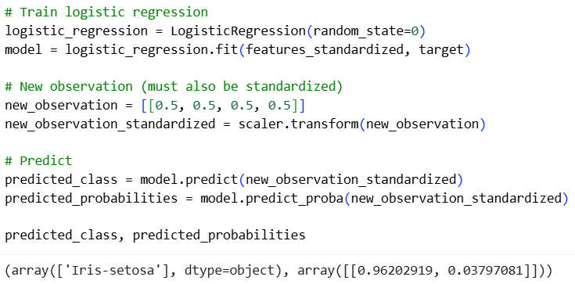

#### B. Training a Multiclass Classifier

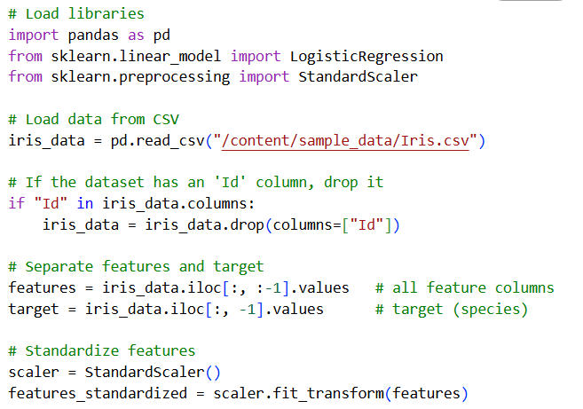

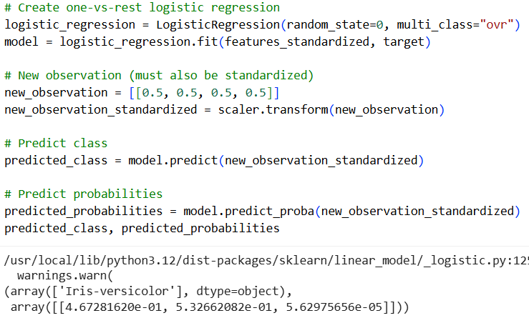

#### C. Reducing Variance Through Regularization

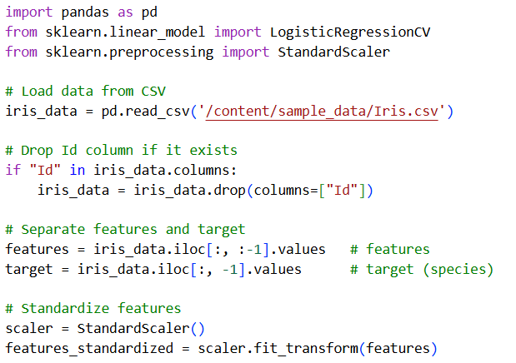

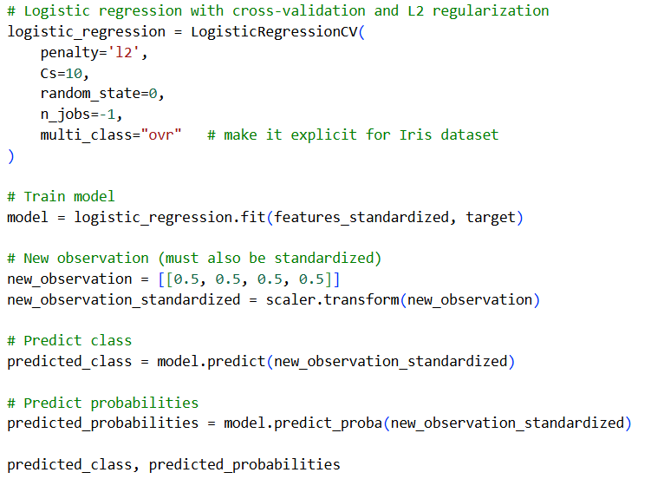

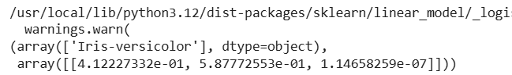

Perform logistic regression for a dataset that shows whether or not college basketball players got drafted into the NBA (draft: 0 = no, 1 = yes) based on their average points, rebounds, and assists in the previous season.

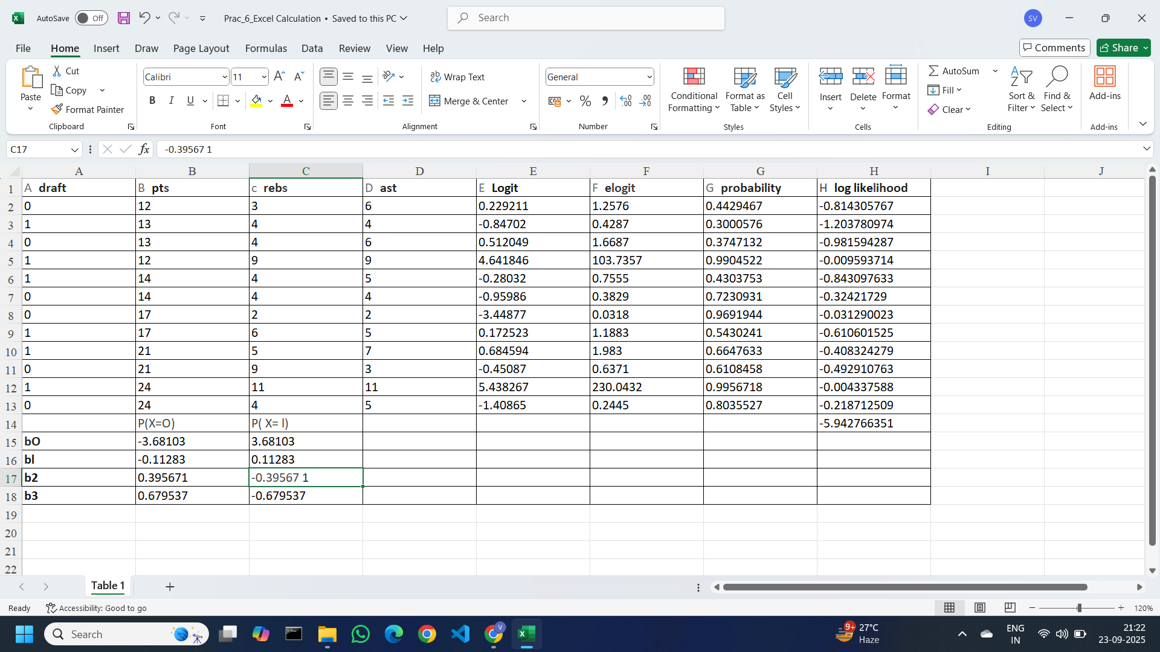

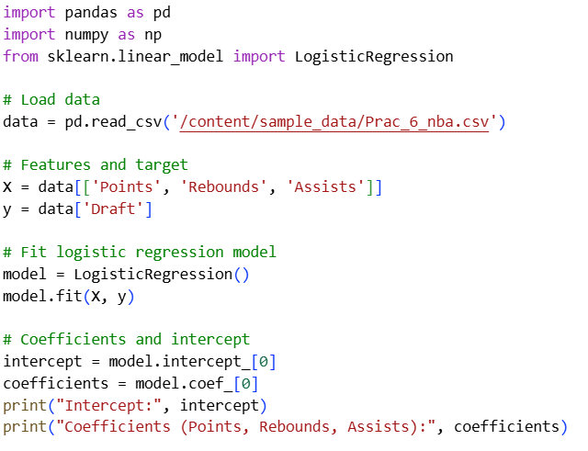

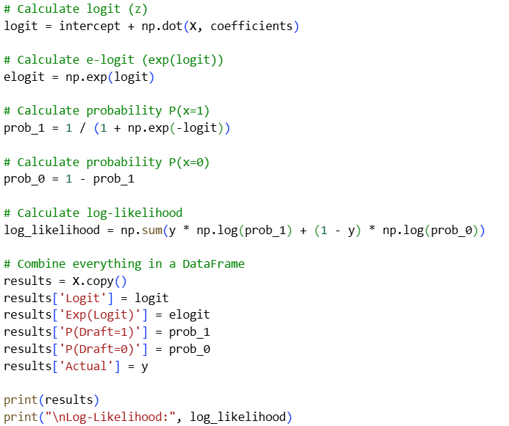

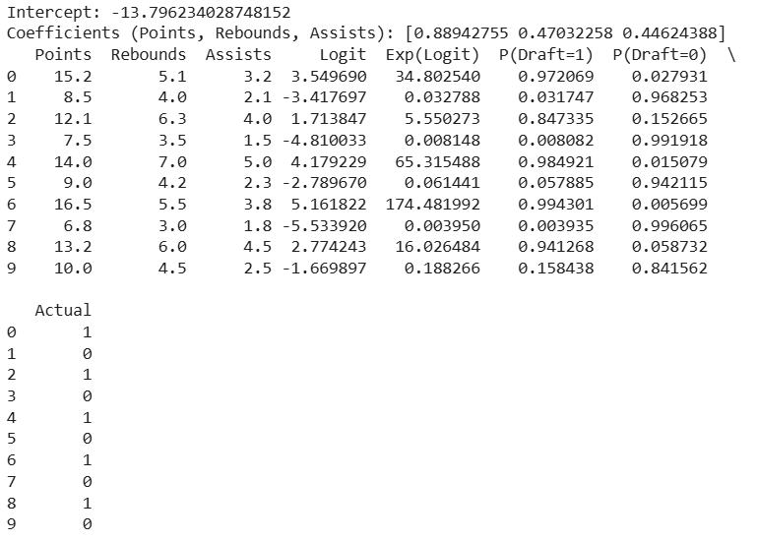

Colab file link: [Prac_6.ipynb](https://colab.research.google.com/drive/10kCmiod5WnutzUsp4cAwCHmjdxBbrEty?usp=drive_link)

### **Practical 7: Support Vector Machines**

Sep 18, 2025

**Support Vector Machine (SVM)** is a supervised learning algorithm used for classification

and regression tasks.

**Objective:** The goal of an SVM is to find the best boundary (or hyperplane) that separates

data points of different classes. For classification, this boundary is chosen to maximize the

margin between the classes.

**How It Works**

1. Hyperplane: In a 2D space, a hyperplane is a line that separates the classes. In higher dimensions, it's a plane or more complex surface.
2. Margin: The margin is the distance between the hyperplane and the closest data points from each class. SVM aims to maximize this margin.
3. Support Vectors: These are the data points closest to the hyperplane and are critical in defining the margin. They lie on the boundary of the margin.
4. Decision Function: For a given point, the SVM decision function will classify it based on which side of the hyperplane it falls on.

**Types**

1. Linear SVM: Used when classes are linearly separable (i.e., you can draw a straight line or hyperplane to separate the classes).
2. Non-Linear SVM: Used when classes are not linearly separable. It applies kernel functions (like the polynomial or radial basis function) to map data into a higher-dimensional space where a linear hyperplane can be used to separate the classes.

**Kernel Trick**

* Linear Kernel: No transformation, used for linearly separable data.
* Polynomial Kernel: Maps data into a higher-dimensional space using polynomial Functions.
* Radial Basis Function (RBF) Kernel: Maps data into an infinite-dimensional space, making it useful for complex decision boundaries.

**Applications**

* Text Classification: SVMs are often used for tasks like spam detection.
* Image Classification: They are effective in distinguishing between different types of Images.
* Bioinformatics: SVMs can classify proteins and genes.

**Advantages**

* Effective in high-dimensional spaces.
* Robust to overfitting, especially in high-dimensional space.

**Disadvantages**

* Can be computationally intensive for large datasets.
* The choice of kernel and parameters can be tricky.

#### A. Training a Linear Classifier

**Importing Libraries**

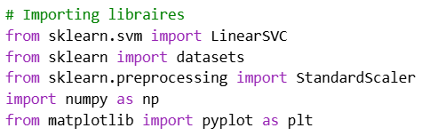

**Loading and Preprocessing Data**

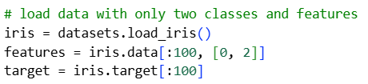

**Standardizing Features**

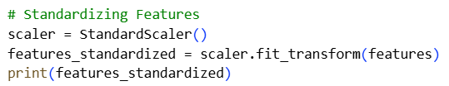

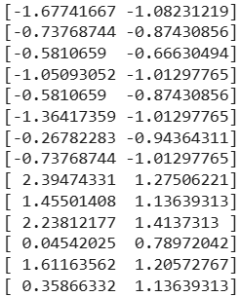

**Creating and Training the Model**

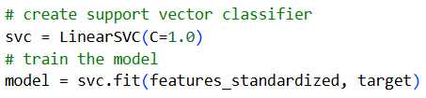

**Plotting the Data and Hyperplane**

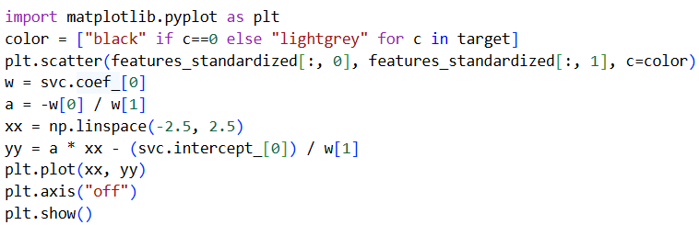

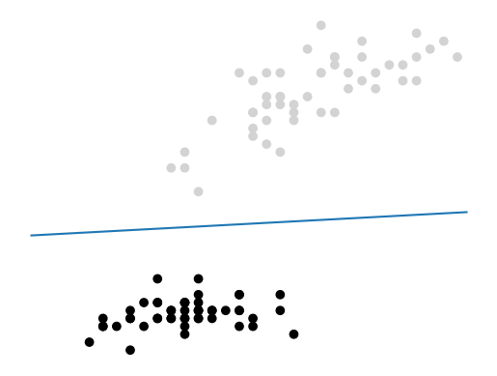

**Making Predictions**

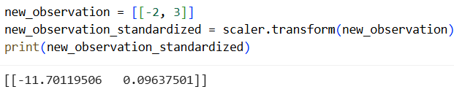

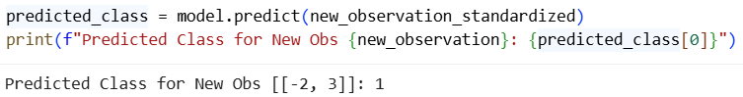

#### B. Handling Linearly Inseparable Classes Using Kernels

**Dataset: Generate the random data in the range of 0 to 200**

**Module required:** **!pip install mlxtend**

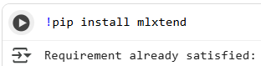

**Import necessary libraries**

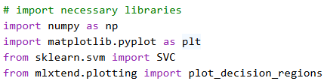

**Generate random data**

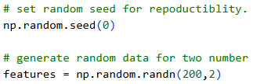

**Create linearly inseparable classes using XOR logic**

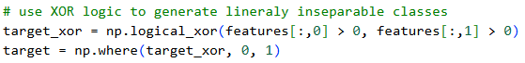

**Train SVM with RBF kernel**

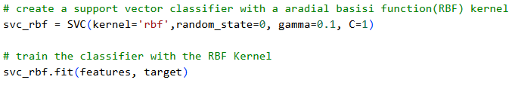

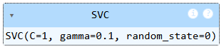

**Train SVM with linear kernel**

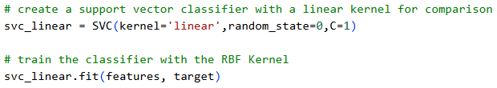

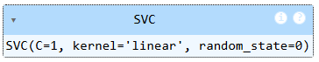

**Plot decision boundaries for the linear kernel:**

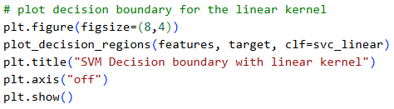

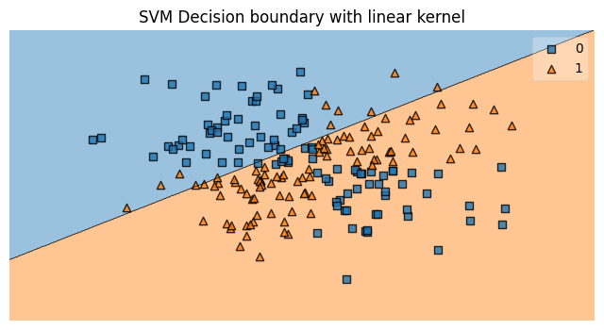

**Plot decision boundaries for the RBF kernel**

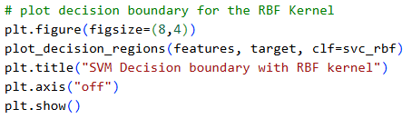

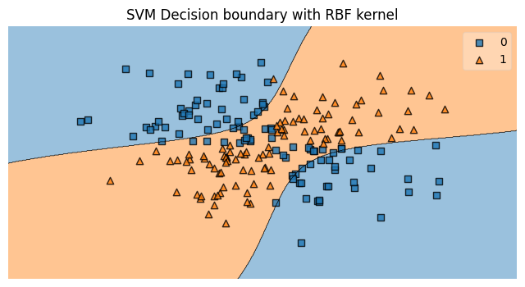

Colab file link: [Prac_7.ipynb](https://colab.research.google.com/drive/1IrfdWOCJk6fGLMyPOB_VsC-09g0HiQRL?usp=drive_link)

### **Practical 8: Naive Bayes**

Sep 18, 2025

**Naive Bayes Classifier with an Example**

The Naive Bayes classifier is a probabilistic machine learning model based on Bayes' Theorem. It assumes that the features used in classification are independent of each other (hence the term "naive"). This simplicity makes it efficient and useful for many tasks, particularly in text classification and spam filtering.

Bayes’ Theorem:

Where: 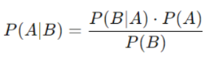

**Example:SpamEmailClassification**

Suppose we want to classify emails as "spam" or "not spam" based on their contents. Using Naive Bayes, we calculate the probability that an email is spam given the occurrence of certain words, like "free" or "money". By calculating the likelihood of each word occurring in spam and non-spam emails and using Bayes' Theorem, we can classify new emails based on their word content.

**Note on Text Analysis**

Text analysis is the process of converting unstructured textual data into structured data to gain meaningful insights. This is widely used in applications like sentiment analysis, text classification, information retrieval, and more. The goal of text analysis is to extract useful information from textual content and enable data-driven decisions. The techniques often involve natural language processing (NLP) methods such as tokenization, stemming, and lemmatization, followed by tasks like sentiment analysis or topic modeling.

**Bag of Words Method**

The Bag of Words (BoW) method is a fundamental technique used in text analysis for converting text into numerical features. It treats text data as a "bag" of words, disregarding grammar and word order, and focuses on word frequency. Each unique word in the dataset becomes a feature, and the value of the feature corresponds to the word’s frequency in the text.

Steps in BoW:

1. Tokenization: Split text into individual words or tokens.
2. Vocabulary Creation: Create a set of unique words from the text.
3. Vectorization: Represent the text by creating a vector where each element corresponds to the count of a word from the vocabulary in the text.

For example, given the two sentences:

* Sentence 1: "I love cats."
* Sentence 2: "I love dogs."

The vocabulary would be: [I, love, cats, dogs]. The sentences would then be represented as vectors:

* Sentence 1: [1, 1, 1, 0] (word 'cats' appears once, 'dogs' does not appear)
* Sentence 2: [1, 1, 0, 1] (word 'dogs' appears once, 'cats' does not appear)

This method is simple but effective for many NLP tasks like document classification.

**Bayesian Network**

A Bayesian Network is a graphical model that represents a set of variables and their conditional dependencies using a directed acyclic graph (DAG). Each node in the graph represents a random variable, and the edges represent the probabilistic dependencies between these variables.

In a Bayesian Network, each node is associated with a probability distribution. The network captures the conditional independence relationships among the variables, which makes it useful for reasoning under uncertainty, particularly in complex domains like medical diagnosis, robotics, and genetics.

For example, a Bayesian Network might be used to model a medical diagnosis where the nodes represent symptoms, diseases, and test results. Given evidence about certain symptoms or test outcomes, the network can calculate the probabilities of different diseases.

**Key Properties:**

* Nodes: Represent random variables (e.g., symptoms, test results).
* Edges: Represent conditional dependencies (e.g., the presence of one symptom depends on a disease).
* Conditional Probability Tables (CPTs): Specify the probability of each node given its parents in the graph.

Bayesian Networks are widely used because they simplify the computation of complex

probabilistic relationships and allow for efficient reasoning and inference.

Dataset: [Prac_8_spam_ham_dataset.csv](https://drive.google.com/file/d/1TjuN08Vt7JKETvbB5MQROL5YEbghBNOX/view?usp=drive_link)

#### A. Training a Classifier for Continuous Features,

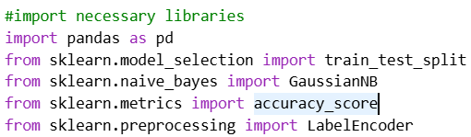

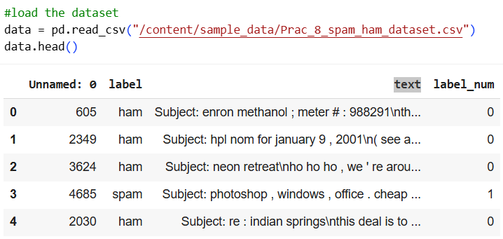

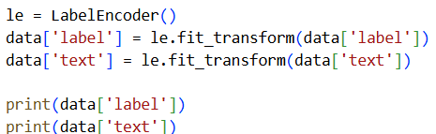

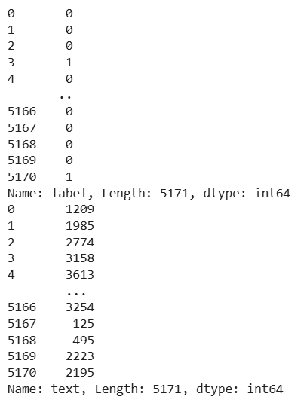

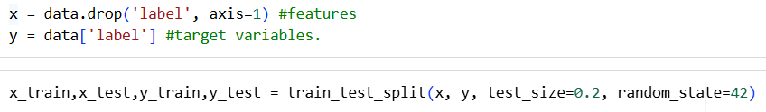

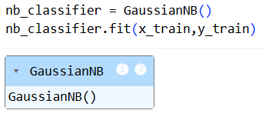

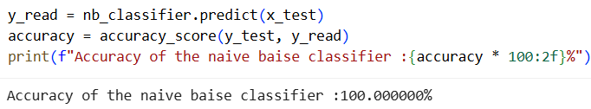



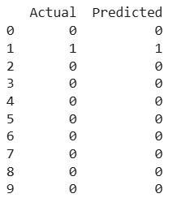

#### B. Training a Naive Bayes Classifier for Binary Features

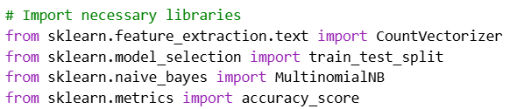

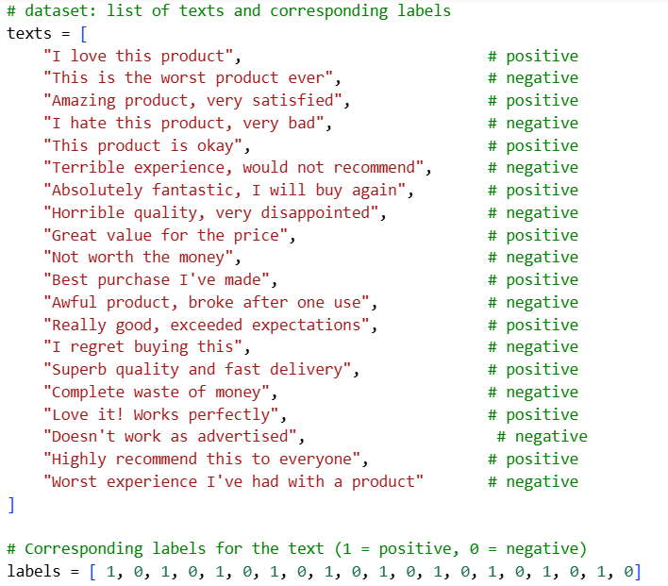

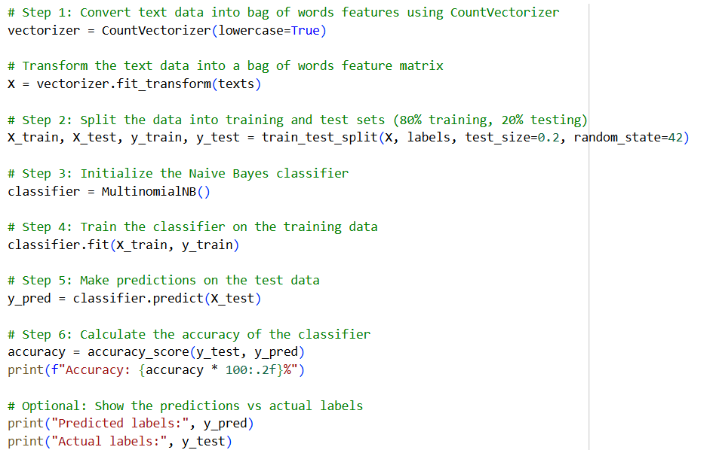

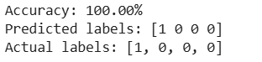

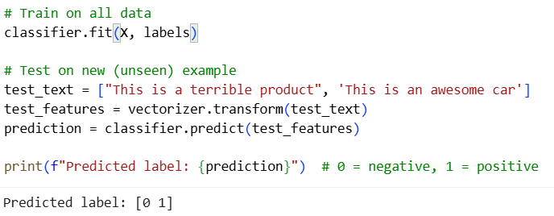

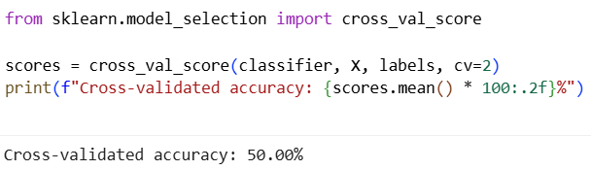

Colab file link: [Prac_8.ipynb](https://colab.research.google.com/drive/1TbLFclDZNk1AQclI3ZbyAgoWaTYZ5TqU?usp=drive_link)

### **Practical 9: Clustering**

Sep 19, 2025

**1. Clustering Using K-Means**

K-Means is a partition-based clustering algorithm that aims to divide a dataset into kkk clusters, where each data point belongs to the cluster with the nearest mean (centroid). The algorithm iterates between assigning data points to the nearest centroid and updating centroids based on the assigned points.

**Advantages:**

* Efficiency: K-Means is computationally efficient and scales well with large datasets.
* Simplicity: The algorithm is straightforward to understand and implement.
* Convergence: It usually converges quickly to a local minimum.

**Disadvantages:**

* Predefined Clusters: The number of clusters kkk needs to be specified in advance, which may not always be known.
* Sensitivity to Initialization: The final clusters can depend on the initial placement of centroids, leading to different results for different runs.
* Assumes Spherical Clusters: It assumes that clusters are spherical and equally sized, which may not be true for all datasets.

**Speeding Up K-Means:**

* K-Means++ Initialization: Improves the choice of initial centroids to help find a better solution and speed up convergence.
* Mini-Batch K-Means: Uses small random samples of the data to update centroids, which speeds up the process for large datasets.

**2. Clustering Using Mean Shift**

Mean Shift is a centroid-based clustering algorithm that iteratively shifts each data point to the average of data points in its neighborhood. It identifies clusters based on the density of data points and does not require specifying the number of clusters in advance.

**Advantages:**

* No Need for kkk: It does not require specifying the number of clusters beforehand.
* Flexible Shape: Can identify clusters of arbitrary shape and size.
* Density-Based: Works well with clusters of varying densities.

**Disadvantages:**

* Computational Complexity: Can be computationally expensive, especially for large datasets.
* Bandwidth Selection: Requires choosing a bandwidth parameter, which can significantly affect the results.

#### A. Clustering Using K-Means: Speeding Up K-Means Clustering

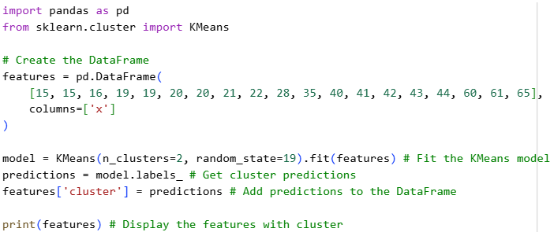

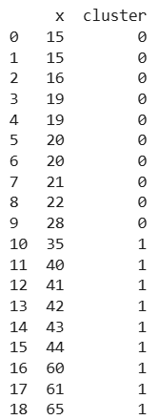

Excel Calulation [Prac_9_Excel_Calculation.xlsx](https://docs.google.com/spreadsheets/d/1NMaBU50EyxTcB1uUAMNFc6THOoMLPGp8/edit?usp=drive_link&ouid=106011563062589671609&rtpof=true&sd=true)

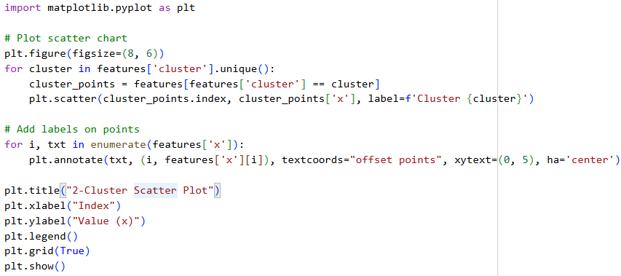

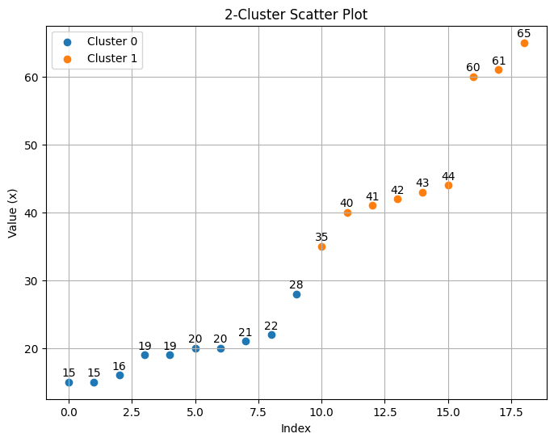

3 Cluster with Data point(X,Y)

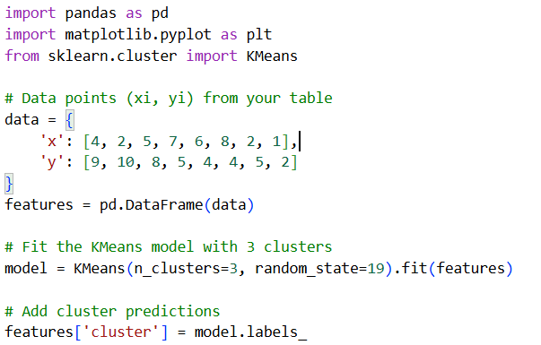

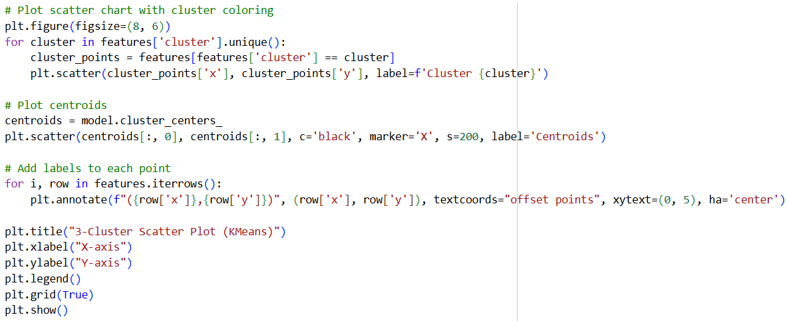

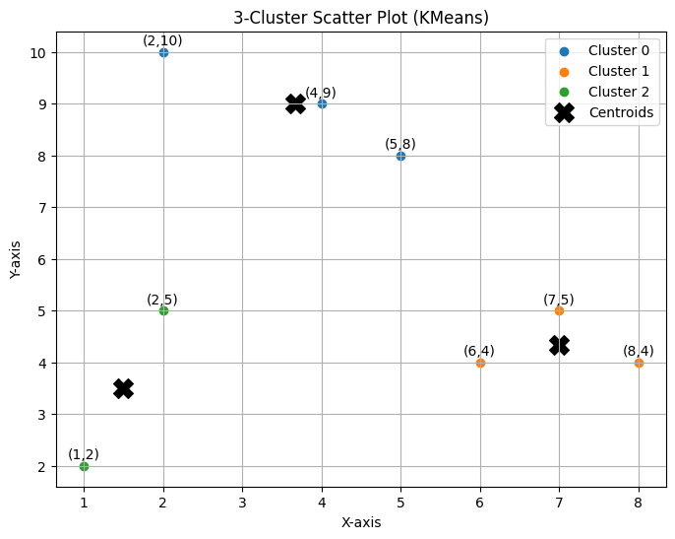

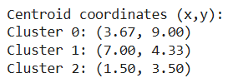

#### 

#### B. Clustering Using Meanshift

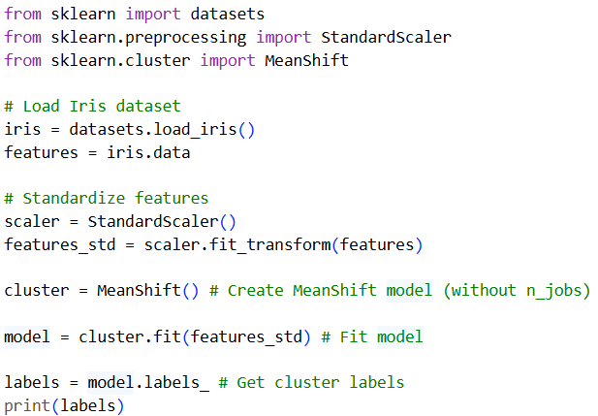

**output**

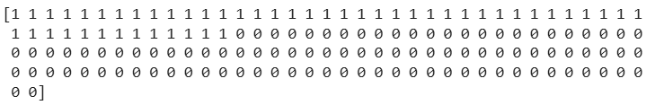

#### C. Clustering Using DBSCAN

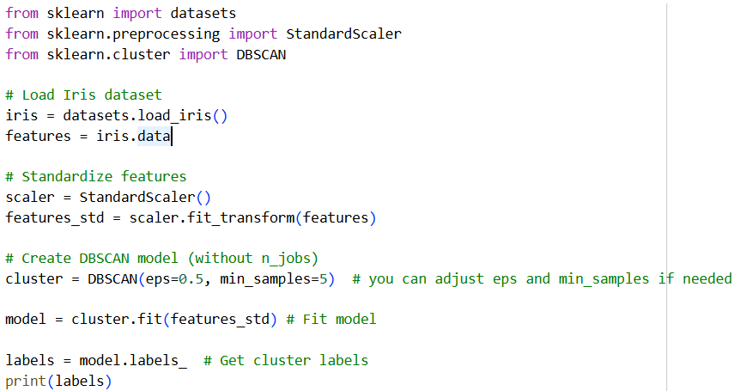

**output**

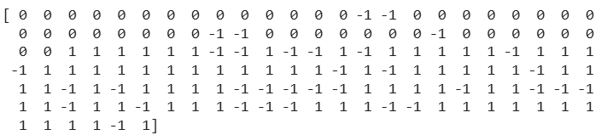

#### D. Clustering Using Hierarchical Merging

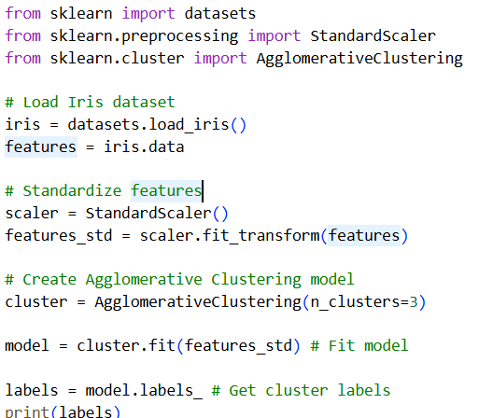

**output**

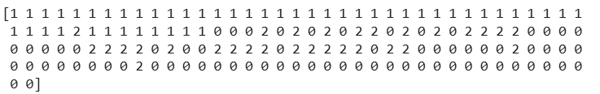

Colab file link: [Prac_9.ipynb](https://colab.research.google.com/drive/19i57O6IfsUv3g64BPlen9yo5IYccFCw8?usp=drive_link)

### **Practical 10: Association rule learning**

Sep 22, 2025

**Apriori Algorithm**

The Apriori algorithm is used for mining frequent itemsets and discovering association rules in transactional datasets. It is commonly used in market basket analysis to identify items that frequently occur together in transactions.

**How It Works:**

**Generate Frequent Itemsets:**

* Step 1: Scan the dataset to count the frequency of each item (1-itemsets) and keep those that meet the minimum support threshold.
* Step 2: Generate candidate itemsets of length kkk from the frequent itemsets
* of length k−1k-1k−1.
* Step 3: Scan the dataset again to count the frequency of these candidate
* itemsets.
* Step 4: Prune the itemsets that do not meet the minimum support threshold.
* Step 5: Repeat steps 2-4 until no more frequent itemsets can be generated.

**Generate Association Rules:**

* Calculate the confidence of these rules and retain the rules that meet the minimum confidence threshold.

**Key Concepts:**

* Support: The proportion of transactions that contain a particular itemset.
* Confidence: The probability that item BBB is purchased when item AAA is Purchased.
* Lift: The ratio of the observed support to the expected support if AAA and BBB were independent.

**FP-Growth Algorithm**

The FP-Growth algorithm is also used for mining frequent itemsets but is generally more efficient than the Apriori algorithm, especially for large datasets. It overcomes the computational inefficiency of generating candidate itemsets by using a more compact data str.

**How It Works:**

**1. Build the FP-Tree:**

Step 1: Scan the dataset to determine the frequency of each item and retain only the items that meet the minimum support threshold.

Step 2: Create the FP-Tree, a compressed tree structure where each node represents an item, and edges represent itemsets. The tree is built in a way that retains itemset counts and maintains itemset ordering.

**2. Mine the FP-Tree:**

Step 1: For each item in the FP-Tree, create its conditional pattern base, which consists of the subset of the database that contains that item.

Step 2: Build a conditional FP-Tree for each conditional pattern base.

Step 3: Recursively mine the conditional FP-Trees to find frequent itemsets.

**Key Concepts:**

FP-Tree: A compact representation of the dataset that stores itemsets in a way that avoids generating candidate itemsets.

Conditional FP-Tree: A tree built from the subset of data related to a specific item, used for finding frequent itemsets that include that item.

**Advantages of FP-Growth Over Apriori:**

* Efficiency: FP-Growth avoids generating a large number of candidate itemsets, making it faster and more scalable.
* Compact Data Structure: The FP-Tree reduces the size of the data needed to be processed, which can lead to faster computations

Ref: [Market Basket Analysis (Apriori, Eclat, FP-Growth)](https://www.kaggle.com/code/andrewtoh78/market-basket-analysis-apriori-eclat-fp-growth)

#### A. Association Rule Learning

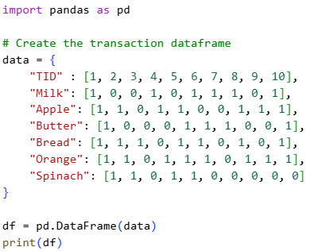

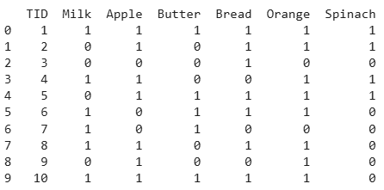

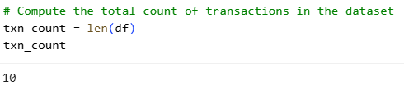

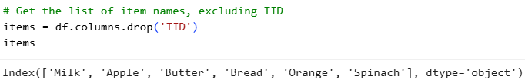

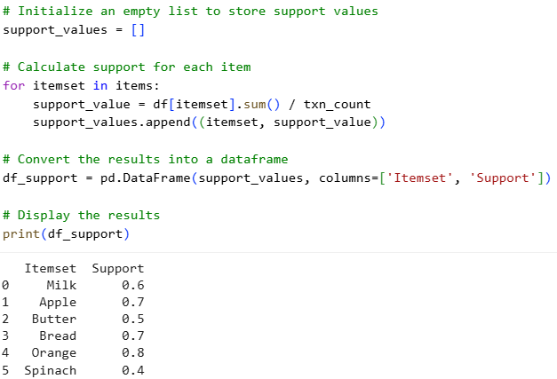

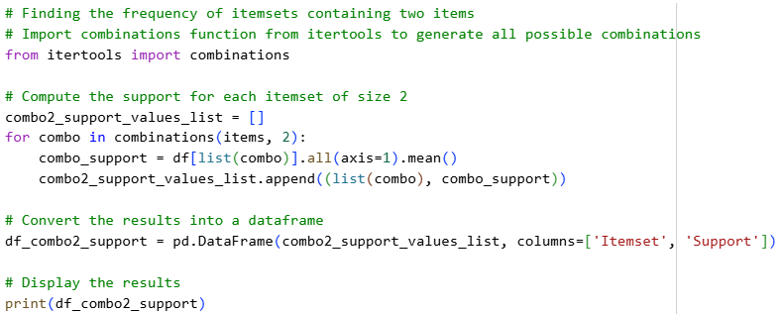

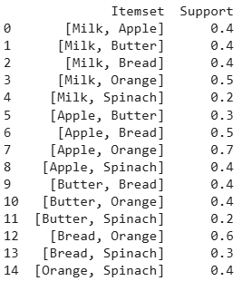

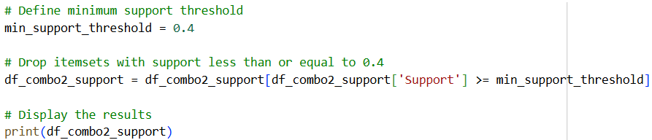

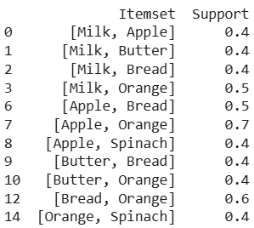

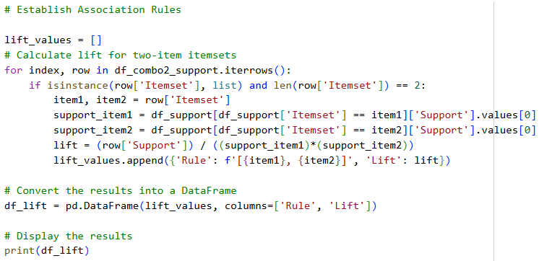

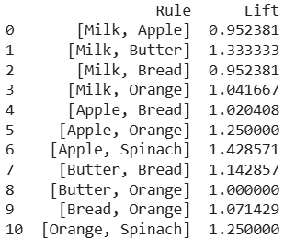

Interpretation of Lift Values

* Lift > 1: Positive association — items are more likely to be bought together than expected by chance.
* Lift = 1: No association — items are bought together exactly as often as random chance.
* Lift < 1: Negative association — items are less likely to be bought together than expected.

*6 [Apple, Spinach] 1.428571*

since the lift of Apple and spinach is maximum then it more frequent to be brought together

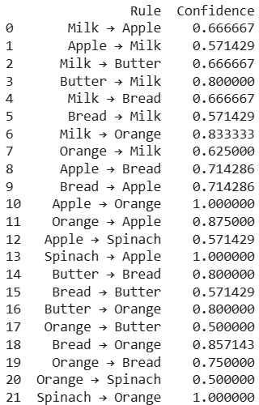

10 Apple → Orange 1.0000 || 13 Spinach → Apple 1.0000 || 21 Spinach → Orange 1.0000

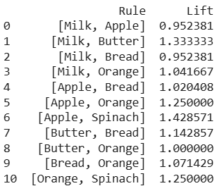

#### B. Apriori algorithm

